

Lab Manual
Subject: Data Mining

By
Abdul Haseeb Arif 2023-BS-AI-033
Semester: 6th
Course Code: DS-303
Supervised by: Mr.Arham
The University of Faisalabad
Bachelors of Science in Artificial Intelligence
DEPARTMENT OF COMPUTER SCIENCE

Sr. No. | Lab Title | Page No.
1 | Lab 1: KNIME Introduction | 1
2 | Lab 2: Customer Churn Prediction | 12
3 | Lab 3: Data Cleaning | 18
4 | Lab 4: Data Preprocessing | 23
5 | Lab 5: Market Basket Analysis | 30
6 | Lab 6: Apriori Algorithm (Product Combination Analysis) | 35
7 | Lab 7: FP-Growth (Efficient Frequent Pattern Mining) | 40
8 | Lab 8: Python Basics (Reusable Data Processing Module) | 45
9 | Lab 9: Decision Tree | 50
10 | Lab 10: Naïve Bayes & KNN | 56
11 | Lab 11: Support Vector Machine (SVM) | 61
12 | Lab 12: Clustering | 67
13 | Lab 13: Outlier Detection | 72
14 | Lab 14: Web Scraping and Sentiment Analysis | 74
15 | Lab 15: Final Capstone Project | 76

Lab 1: KNIME Introduction

- Real World Problem:
A retail business has accumulated transactional sales data spanning multiple product categories. However, raw data alone offers little actionable insight without proper analysis. The management requires structured analytical results to assess total revenue performance, understand average customer order spending, determine which categories generate the highest income, and pinpoint the most profitable products.
- Dataset:
The dataset used in this lab is a Retail Sales CSV file containing transaction-level records.
Each row corresponds to a single sales transaction and includes relevant attributes such as:
- Transaction ID
- Product Name
- Product Category
- Quantity
- Price per Unit
- Order Date
- Total Amount (or Revenue calculated during analysis)
The dataset structure allows aggregation, comparison, and ranking of sales performance across different dimensions.

- Software Environment:

The Software Environment used in this Lab is KNIME

- KNIME Analytics Platform
KNIME is a visual, node-based data analytics tool that enables users to build structured workflows for data processing and analysis. Each node performs a specific operation such as reading data, transforming attributes, computing statistics, or aggregating values.
The connected nodes together form a complete analytical pipeline that converts raw data into meaningful business metrics.

- Practical Objectives:
By completing this lab, students will gain practical experience in using KNIME for structured data analysis. Specifically, students will be able to:
- Import a CSV dataset into a KNIME workflow using the CSV Reader node.
- Examine and correct column data types to ensure computational accuracy.
- Generate descriptive statistical summaries to understand dataset characteristics.
- Create a calculated Revenue column using the Math Formula node.
- Compute four key retail performance indicators using GroupBy and Sorter nodes.

- Procedure:

Step 1: Download the Dataset:
Obtain the Retail Sales dataset in CSV format from the provided source and save it locally for analysis.
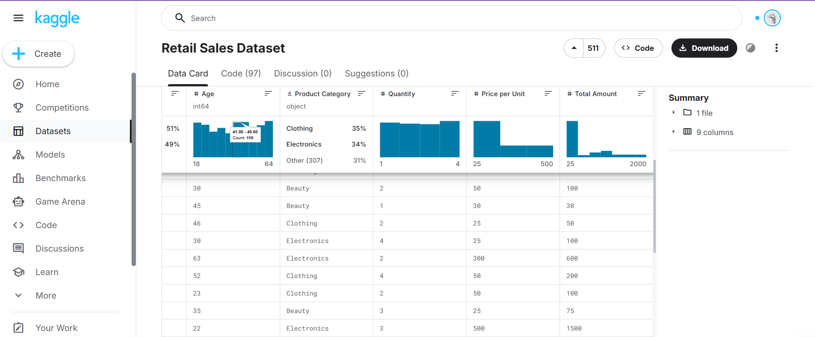

Step 2: Create a New Workflow
Launch KNIME Analytics Platform and create a new workflow named Retail Sales Analysis to organize the analytical process.
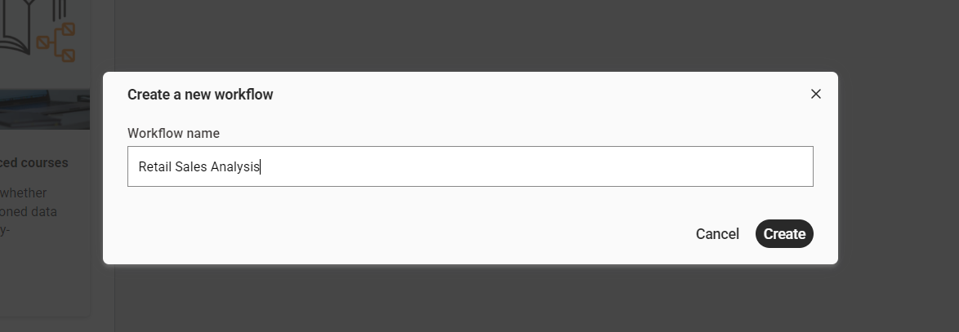

Step 3: Import the Dataset:
Use the CSV Reader node to load the Retail Sales dataset into the workflow environment and verify successful execution.
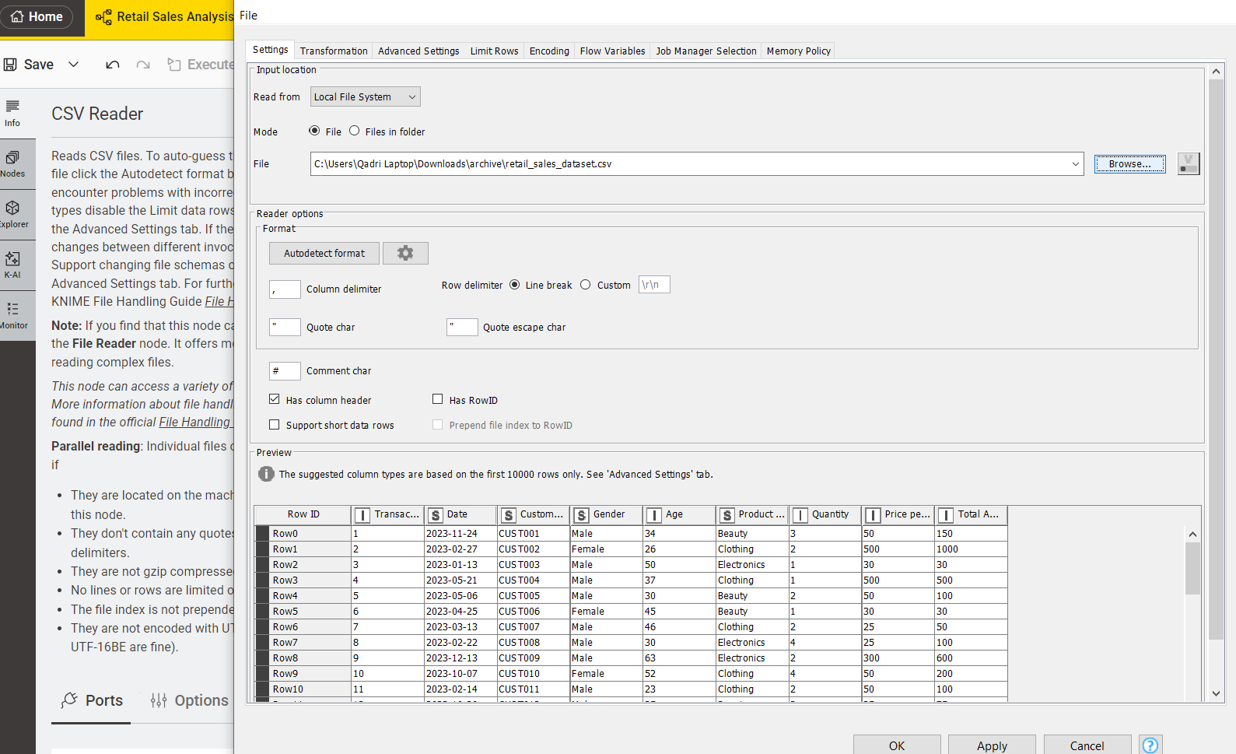

Step 4: Verify the Data Types
Inspect all columns to ensure numeric fields (Quantity, Price, Revenue) are correctly typed as Integer or Double, and categorical fields (Category, Product Name) are set as String.
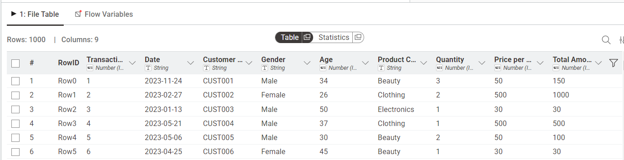

Step 5: Generate Summary Statistics:
Apply the Statistics node to compute descriptive measures such as mean, minimum, maximum, sum, and standard deviation for numeric attributes.
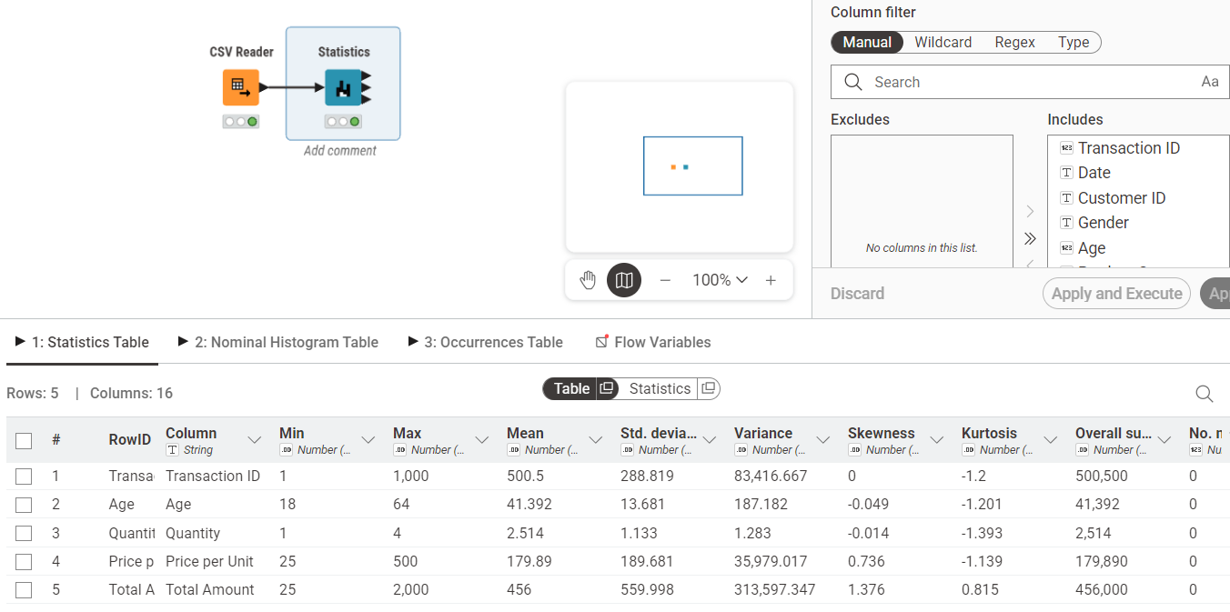

Step 6: Calculate Revenue Column:
Use the Math Formula node to create a new Revenue column using the formula:
Revenue = Quantity × Price
This derived column will be used for KPI calculations.
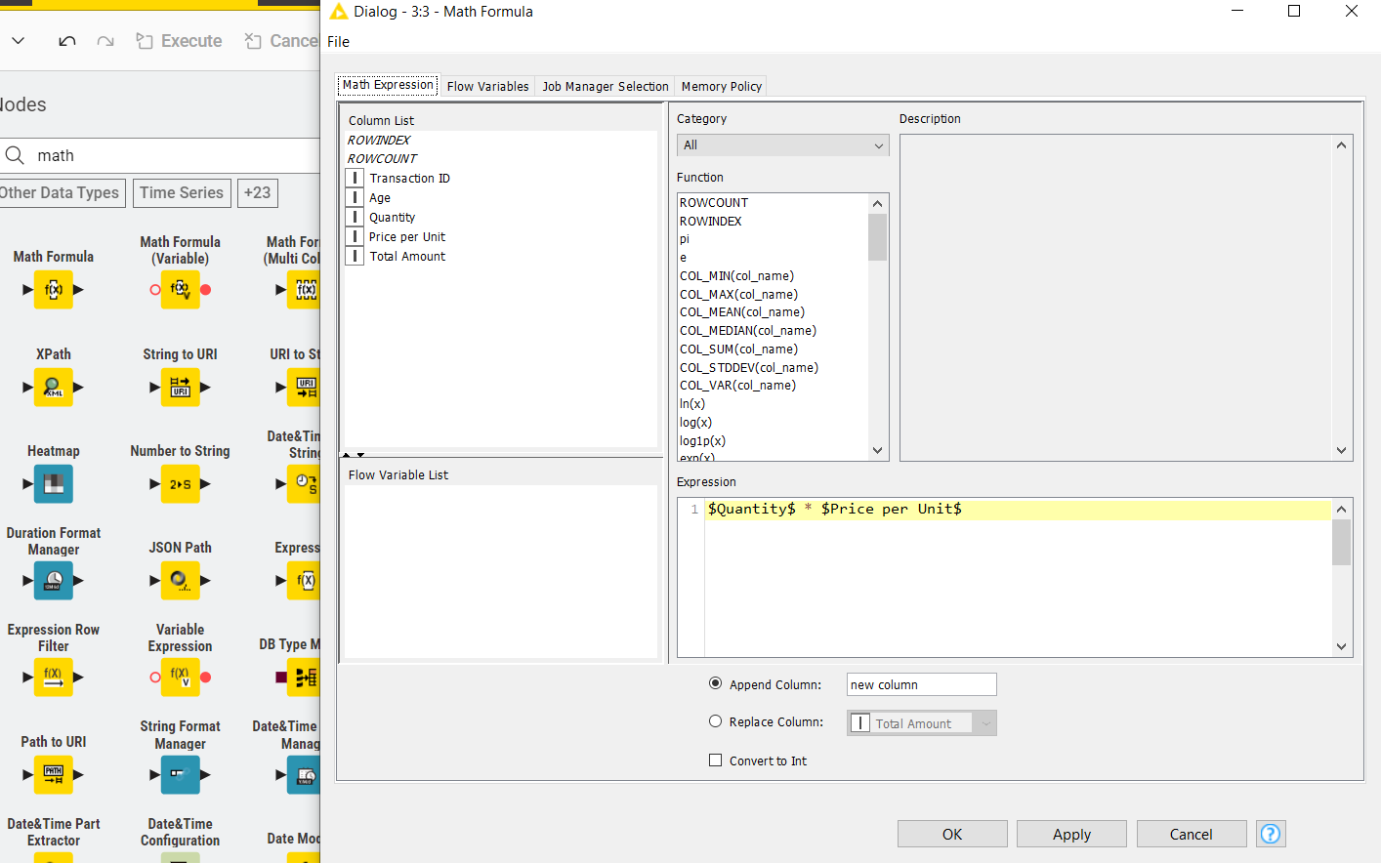
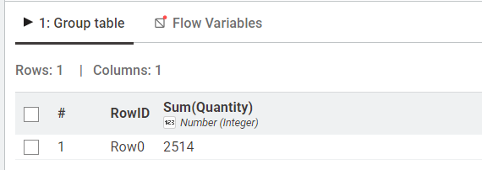

Step 7: Calculate Total Revenue (KPI 1 – Total Revenue):
Add a GroupBy node without selecting any grouping column and aggregate the Revenue column using the Sum function to compute overall sales revenue.
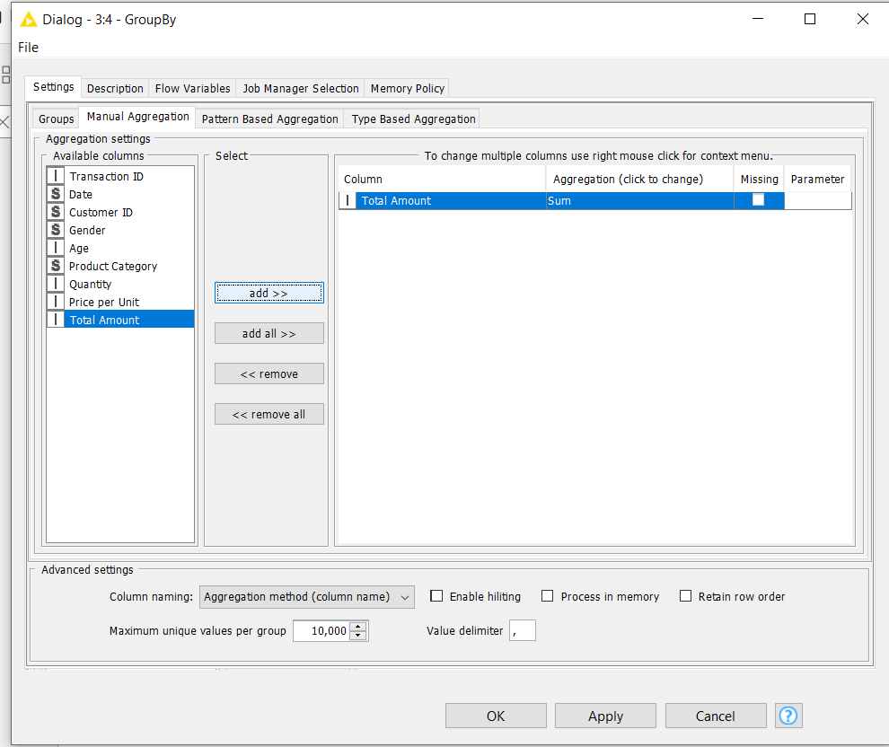

Step 8: View Total Revenue Result:
Execute the node and observe the single output value representing total revenue across all transactions.
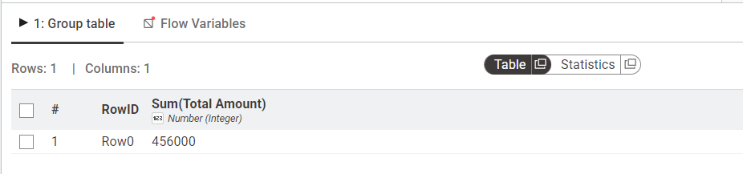

Step 9: Calculate Revenue per Transaction
Add a GroupBy node, group by Transaction ID, and aggregate Revenue using Sum to compute total revenue for each individual order.
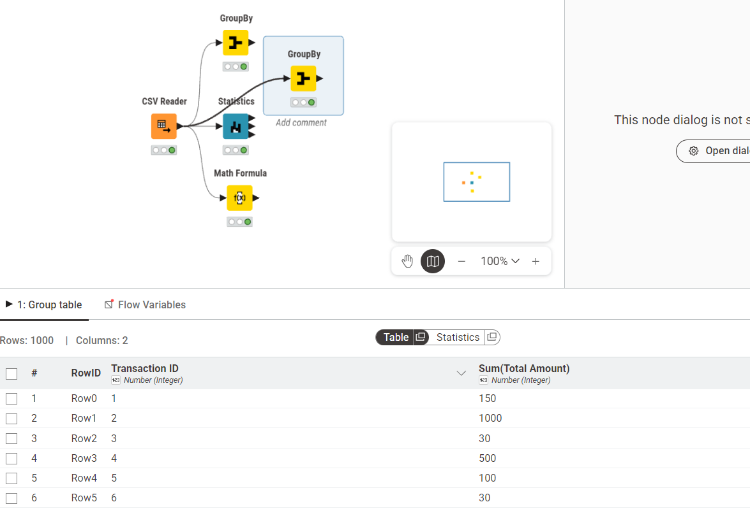

Step 10: Calculate Average of All Orders (KPI 2 – Average Order Value)
Connect a second GroupBy node with no grouping column and calculate the Mean of the aggregated revenue to determine the average order value.
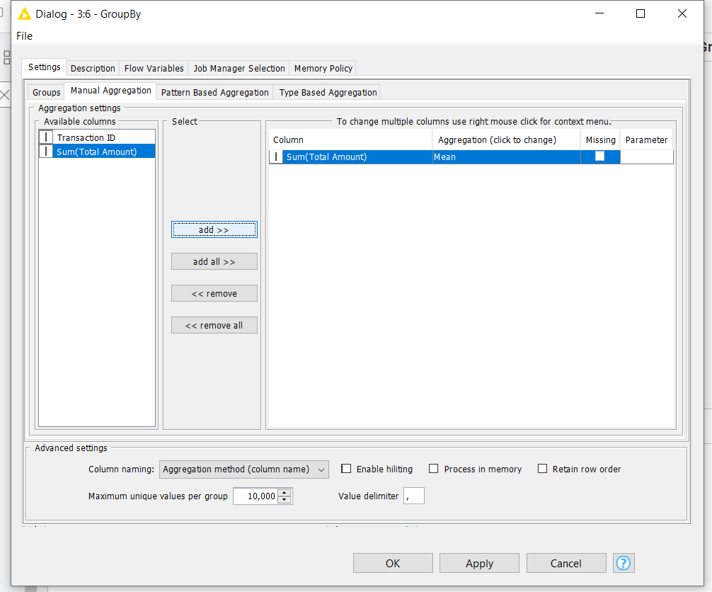

Step 11: View Average Order Value Result:
Execute and review the output showing the average revenue generated per transaction.
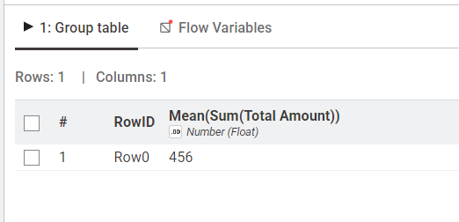

Step 12: Calculate Category Revenue (KPI 3 – Revenue by Category):
Add a GroupBy node and group by Product Category. Aggregate Revenue using Sum to compute total earnings for each category.
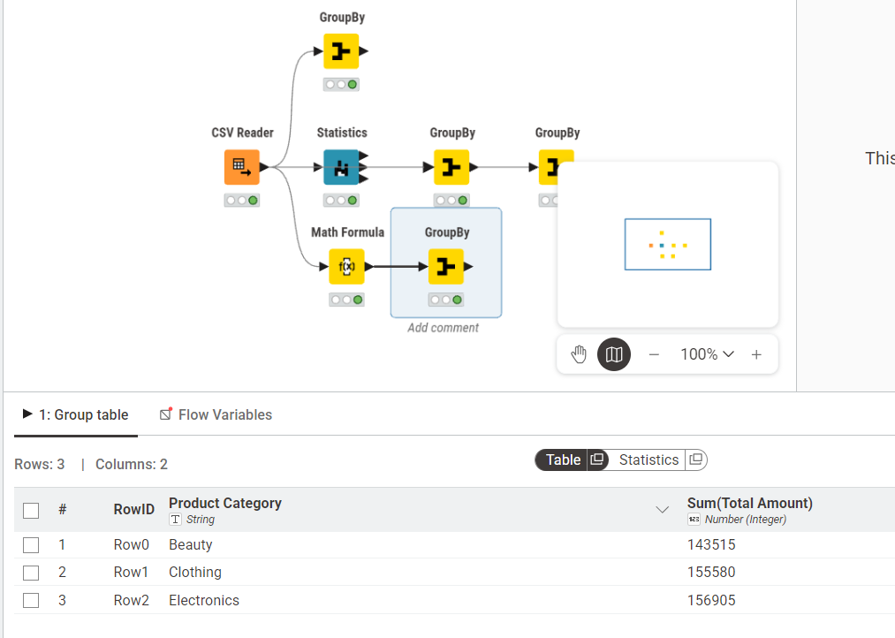

Step 13: Sort to Identify Highest Revenue Category
Connect a Sorter node and configure it to sort revenue values in descending order to rank categories from highest to lowest.
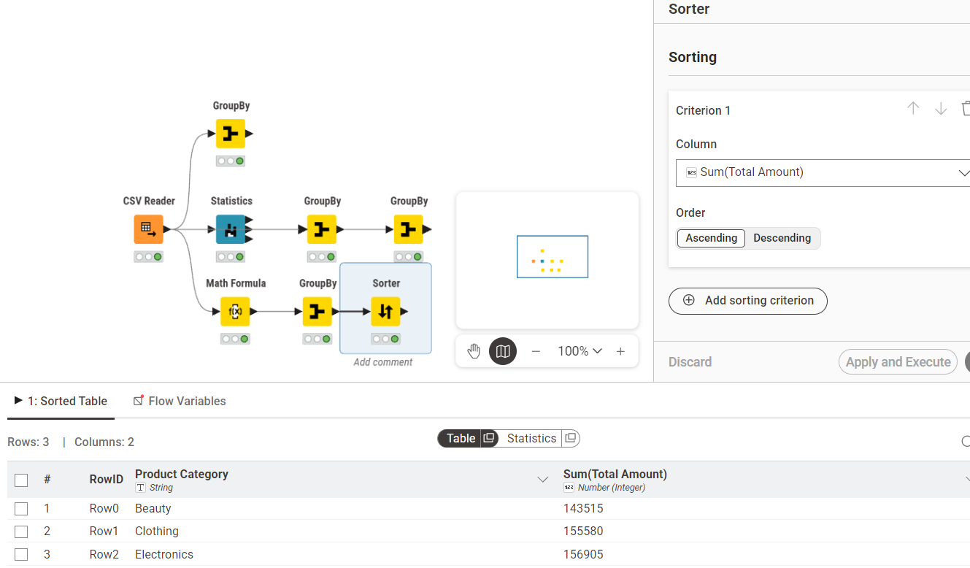

Outcome of the Lab:
This lab demonstrates how raw transactional sales data can be systematically transformed into structured performance metrics.
The workflow converts:
Raw Data → Processed Data → Aggregated Metrics → Business Insights
Through structured node-based operations, the analysis provides measurable indicators that support revenue evaluation, category comparison, and product performance assessment.

Lab 2: Customer Churn Prediction

- Real-World Problem:
An e-commerce company aims to identify which customers are likely to discontinue their service. Without early detection, the company faces revenue loss and misses critical retention opportunities. This lab applies the CRISP-DM methodology and Orange Data Mining to construct a churn prediction model using customer account data.
- Dataset:
The dataset used is Churn_Modelling.csv containing 10,000 customer records with 14 attributes. The target variable is Exited (1 = Churned, 0 = Retained). Key features include CreditScore, Geography, Gender, Age, Tenure, Balance, NumOfProducts, HasCrCard, IsActiveMember, and EstimatedSalary. Irrelevant columns RowNumber, CustomerId, and Surname were removed during preparation.
- Software Environment:
The Software Environment used in this Lab is Orange.
- Orange Data Mining:
Orange is an open-source visual analytics platform that allows users to build data mining workflows by connecting widgets on a canvas. It supports data loading, preprocessing, classification, and evaluation without requiring any code.

Practical Objectives
- Load and inspect a CSV dataset using the File and Data Table widgets.
- Remove irrelevant columns and set the target variable using Select Columns.
- Normalize and encode features using the Preprocess widget.
- Train Logistic Regression and Random Forest classification models.
- Evaluate and compare models using Test and Score with 10-fold cross validation.
- Interpret results through Confusion Matrix and ROC Analysis.
- Calculate Churn Rate and Retention Rate as business KPIs.

- Procedure:
Step 1: Load the Dataset
Use the File widget to load Churn_Modelling.csv and connect it to a Data Table widget to verify all 10,000 rows and 14 columns are loaded correctly.

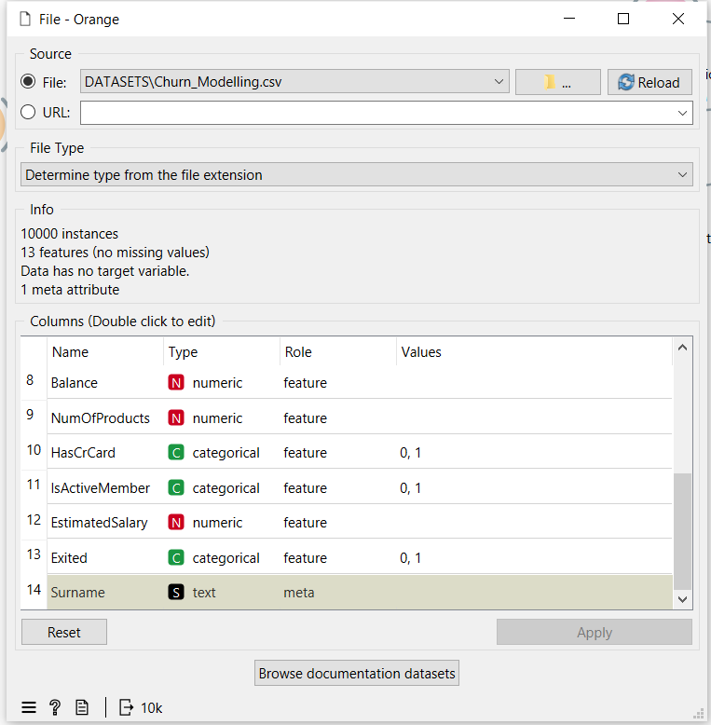
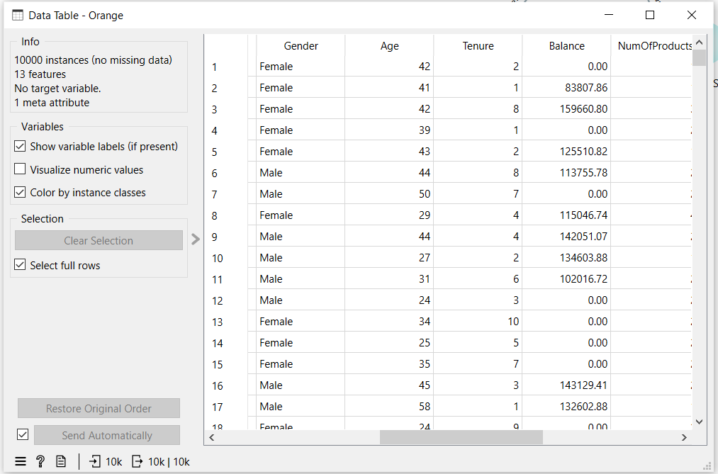

Step 2: Select Columns
Connect to a Select Columns widget. Move RowNumber, CustomerId, and Surname to the Ignore list. Set Exited as the Target class and keep all remaining features.
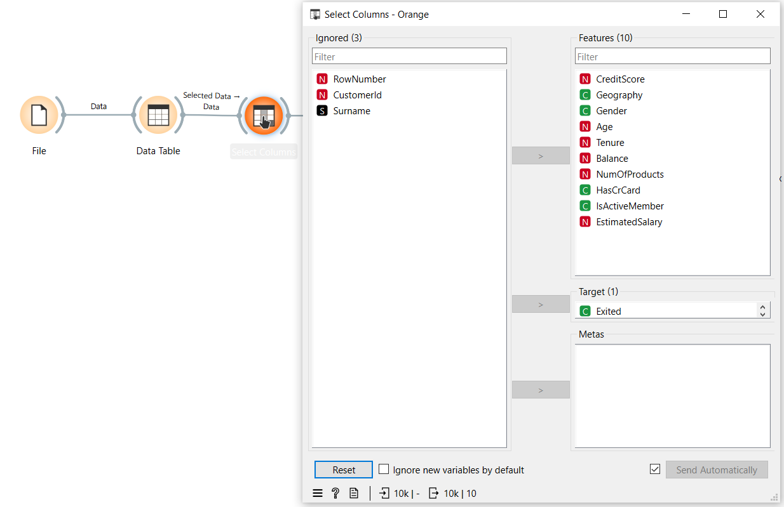

Step 3: Preprocess
Connect to a Preprocess widget and enable Min-Max normalization to scale all numeric features between 0 and 1.
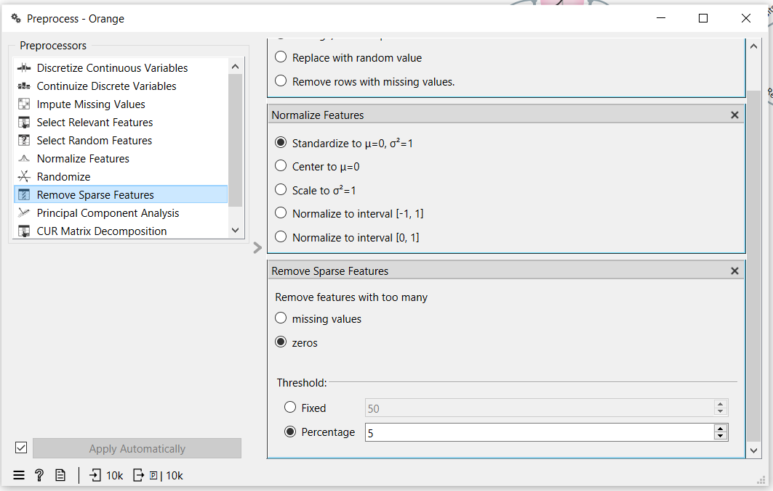

Step 4: Add Models
Connect the Preprocess widget to both a Logistic Regression widget and a Random Forest widget using the Preprocessor output port.
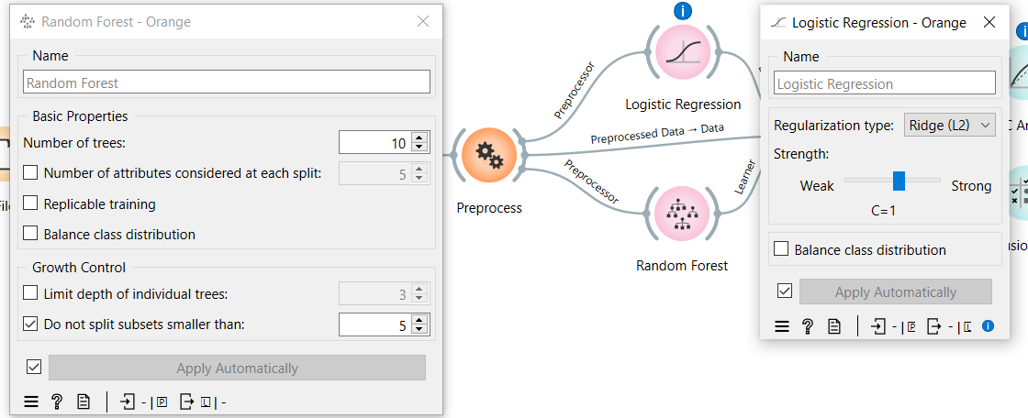

Step 5: Test and Score
Connect both learners and the preprocessed data to the Test and Score widget. Set evaluation to Cross Validation with 10 folds and enable Stratified splitting.
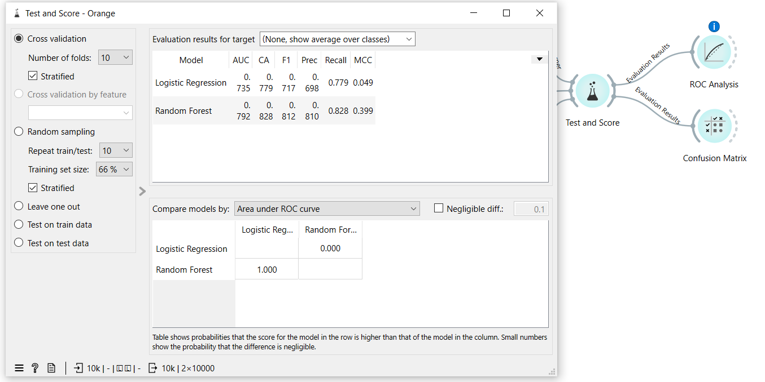

Step 6: Evaluate
Connect Test and Score to a ROC Analysis widget and a Confusion Matrix widget to visualize model performance.
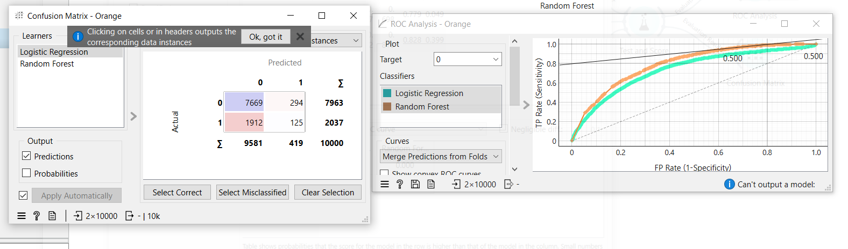

- Outcome of the Lab:
This lab demonstrates how raw customer data can be processed and modeled to predict churn using a complete CRISP-DM pipeline in Orange.
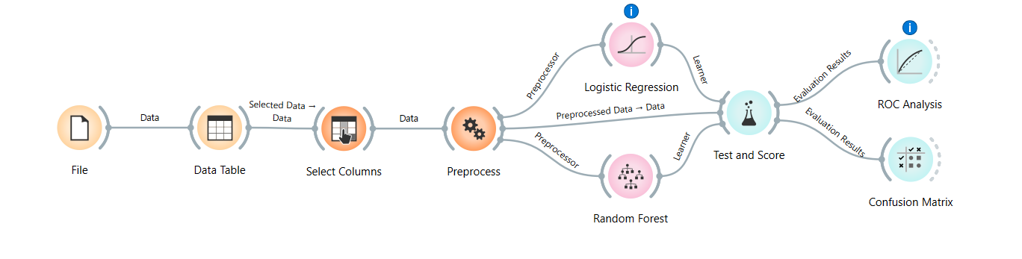
Random Forest outperformed Logistic Regression across all metrics. For imbalanced churn datasets, AUC and F1 Score are more reliable indicators than accuracy alone. The model can be deployed to score customers and trigger early retention actions for high-risk segments.

KPI | Result
Churn Rate | 20.37%
Retention Rate | 79.63%
Logistic Regression AUC | 0.735
Random Forest AUC | 0.792
Random Forest Accuracy | 82.8%
Random Forest F1 Score | 0.812

Lab 3: Data Cleaning

Real-World Problem
Raw healthcare datasets often contain clinical noise, such as missing entries, redundant records, and illogical values (e.g., negative billing amounts). These inconsistencies can lead to inaccurate medical analysis and poor decision-making. To ensure the reliability of patient data for healthcare analytics, a systematic data cleaning workflow is required to refine the raw records into an analysis-ready format.

Dataset Overview
The analysis uses a Healthcare Dataset containing transaction-level patient records.
- Total Records: 55,500 rows and 15 columns.
- Key Attributes: Patient Name, Age, Gender, Blood Type, Medical Condition, Billing Amount, Admission Type, and Medication.
- Cleaning Targets: Standardizing text casing, handling missing values, and filtering out illogical numerical outliers.

Software Environment
- RapidMiner Studio / Python (Pandas & NumPy): Utilized for programmatic data manipulation and cleaning workflows.

Practical Objectives
- Handle Missing Values: Identify and resolve gaps in patient records.
- Remove Duplicates: Eliminate redundant entries to maintain data integrity.
- Noise Filtering: Resolve clinical noise by standardizing text and removing illogical numerical outliers.
- Calculate KPIs: Measure cleaning effectiveness through % Missing Reduced, Duplicate Removal %, and Data Quality Score.

Procedure & Steps
Step 1: Environment Setup & Data Loading
Initialize the environment by importing necessary libraries (Pandas, NumPy) and loading the healthcare dataset for inspection.
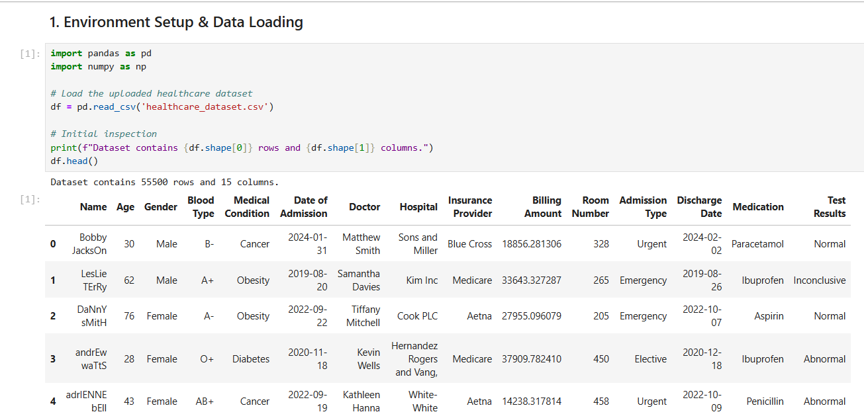

Step 2: Initial Data Inspection
Check the dataset dimensions and identify initial issues like missing values across different columns.
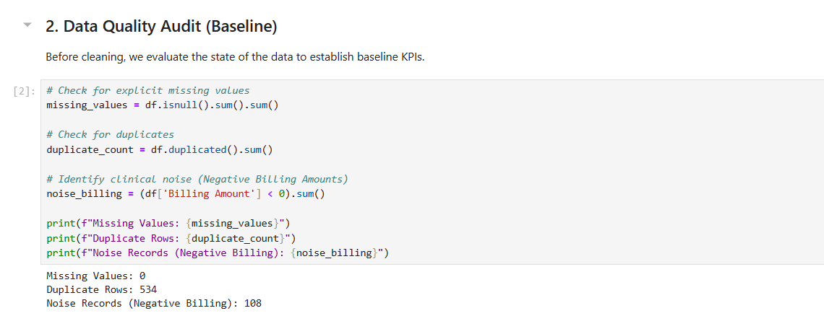

Step 3: Duplicate Record Removal
Scan the dataset for identical patient entries and remove redundant rows to ensure each record is unique.
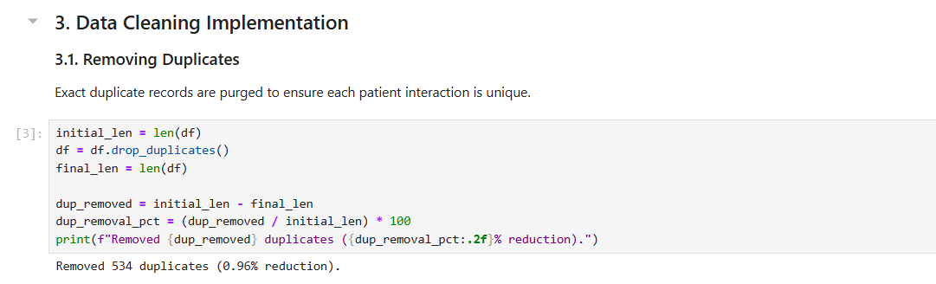
Step 4: Clinical Noise Filtering & Standardizing
Standardize text casing (e.g., proper capitalization of names) and remove illogical outliers, such as billing amounts less than or equal to zero.
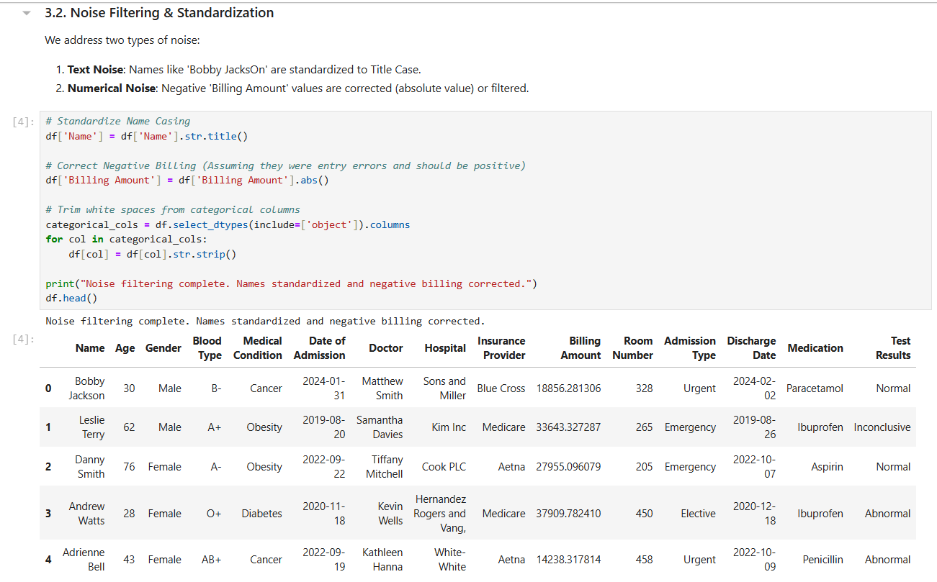

Step 5: KPI Calculation
Compute performance metrics to verify the quality of the cleaned data, including the final Data Quality Score.
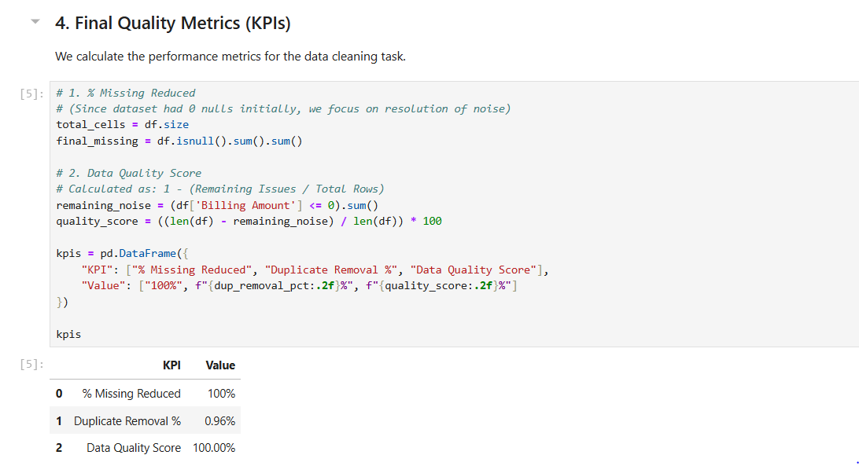
Step 6: Export Cleaned Data
Save the final processed dataset as a new file (e.g., cleaned_healthcare_data.csv) for future analysis. 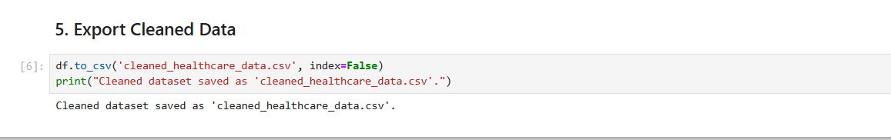

Outcome of the Lab
This lab demonstrates the critical role of data preprocessing in the healthcare analytics pipeline. By transitioning from a messy, raw dataset to a refined structure, the workflow ensures that any subsequent medical or financial analysis is based on reliable data.
The key outcomes include:
- Data Integrity: Successfully eliminated clinical noise and redundant patient records, preventing skewed results in population health reporting.
- Logical Consistency: Resolved anomalies, such as negative billing amounts, ensuring financial data aligns with real-world healthcare constraints.
- Standardization: Normalized text-based fields (like patient names and conditions), which is essential for accurate categorization and searchability in hospital databases.
- Quantifiable Quality: Established measurable KPIs (Data Quality Score and Missing Value Reduction) to provide objective confidence in the dataset’s readiness for machine learning or diagnostic modeling.

Lab 4: Data Preprocessing

Real-World Problem
A bank needs to assess loan risk before approving applications. Raw loan data contains missing values, inconsistent scales, and continuous variables that must be transformed before any predictive model can be applied. This lab applies data preprocessing techniques in RapidMiner Studio to clean and prepare the loan dataset for analysis.

Dataset
The dataset used is loan_dataset_20000.csv containing 20,000 loan application records. Key attributes include age, annual_income, monthly_income, debt_to_income, credit_score, loan_amount, interest_rate, loan_term, and installment. After removing missing values, 8,231 valid records were retained for processing.

Software Environment
RapidMiner Studio
RapidMiner is a visual data science platform that allows users to build analytical workflows by connecting operators. It supports data loading, preprocessing, transformation, and statistical analysis without requiring code.

Practical Objectives
By completing this lab, students will be able to:
- Load a CSV dataset using the Retrieve operator.
- Handle missing values using the Replace Missing Values operator.
- Normalize numeric features using Z-Score normalization.
- Apply Z-Score Peak Transformation to handle outliers.
- Discretize continuous variables into categorical bins.
- Generate summary statistics using the Statistics operator.
- Calculate Variance Reduction and Distribution Improvement as KPIs.

- Procedure
Step 1: Load the Dataset
Use the Retrieve operator to load loan_dataset_20000.csv into the workflow. Connect it to the next operator to begin preprocessing.
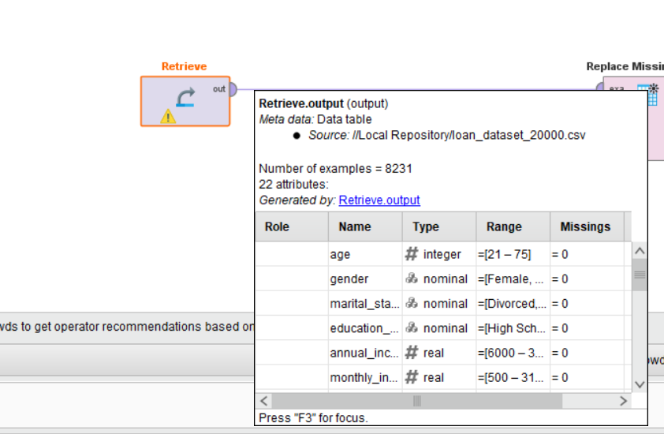
Step 2: Replace Missing Values
Connect to a Replace Missing Values operator. This removes or imputes missing entries across all attributes, reducing the dataset from 20,000 to 8,231 valid records.
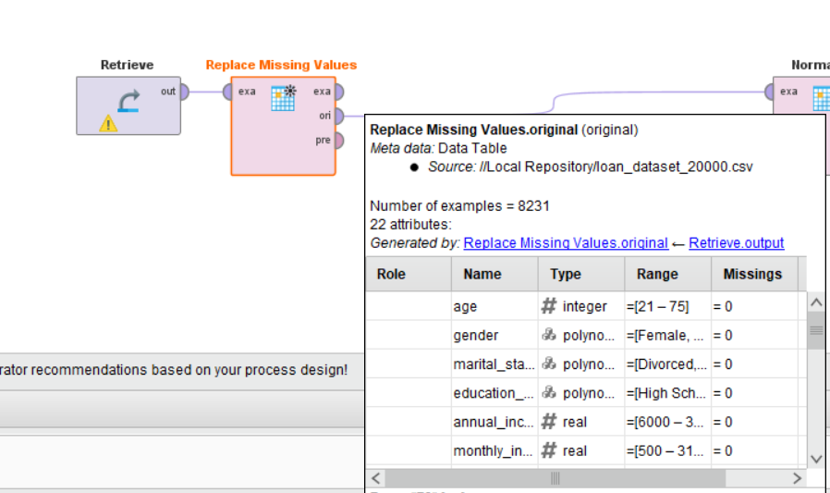
Step 3: Normalize
Connect to a Normalize operator and apply Z-Score normalization. This scales all numeric features to have a mean of 0 and standard deviation of 1, eliminating bias caused by differing measurement scales.
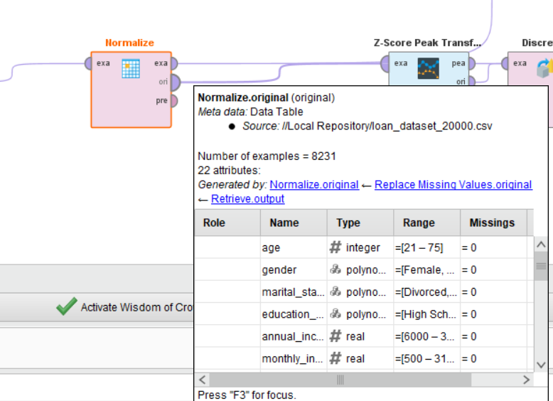
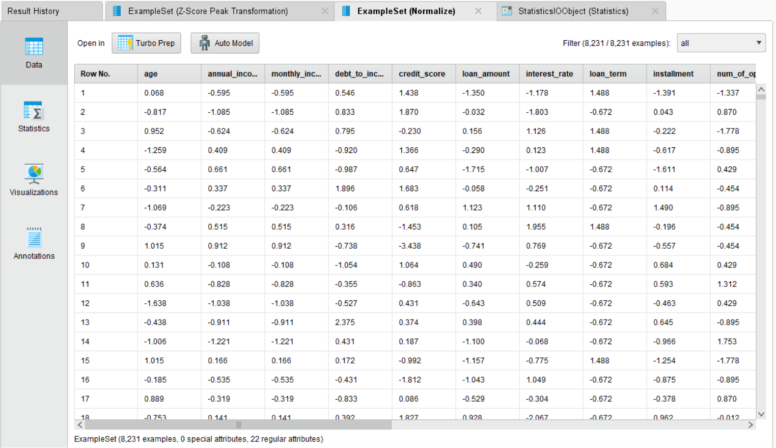

Step 4: Z-Score Peak Transformation
Connect to a Z-Score Peak Transformation operator. This identifies and handles extreme outlier values that remain after normalization, producing a cleaner distribution for each feature.
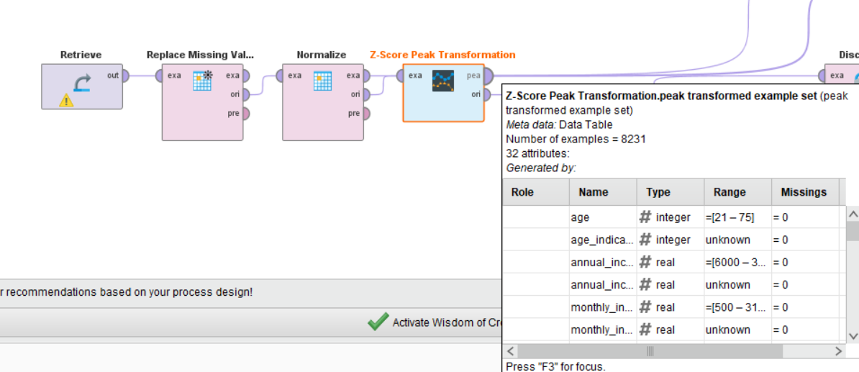
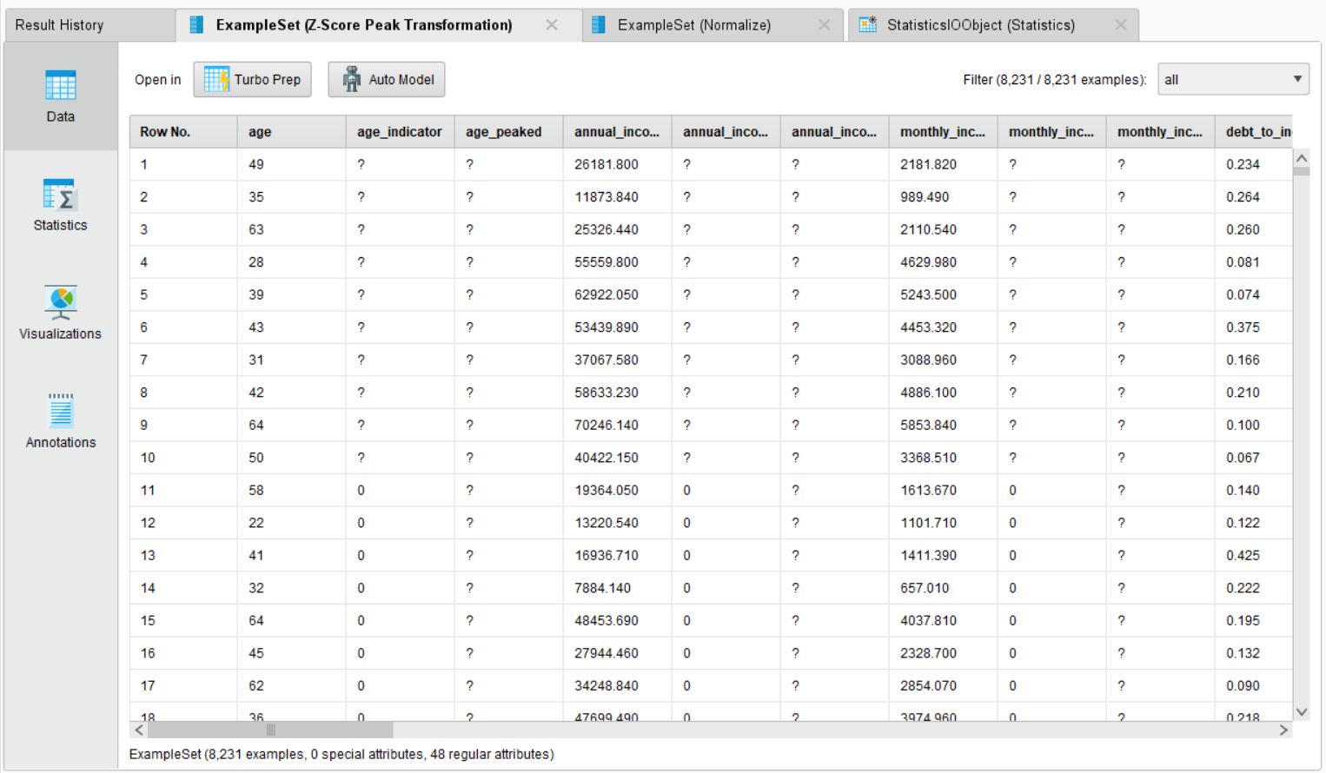

Step 5: Discretize
Connect to a Discretize operator. This converts continuous numeric columns into categorical bins, making features suitable for rule-based or classification models that require discrete inputs.
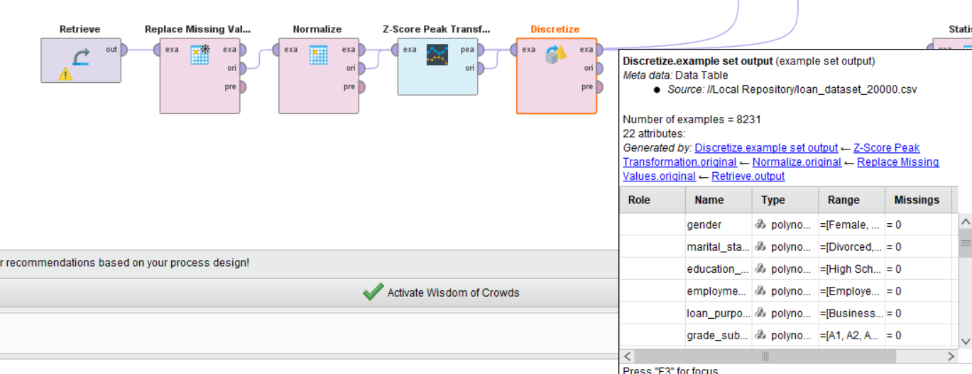
Step 6: Generate Statistics
Connect all result outputs to a Statistics operator. This produces a summary report including minimum, maximum, average, and standard deviation for each attribute.
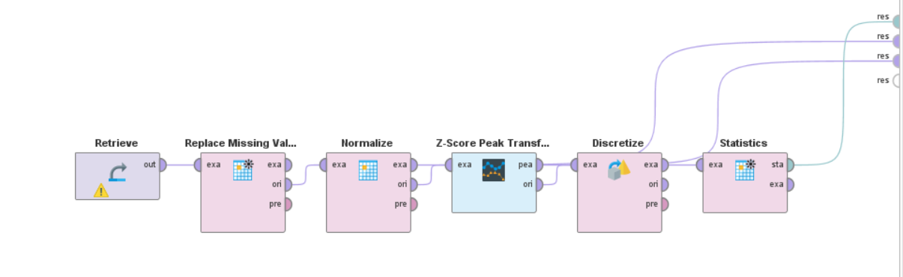
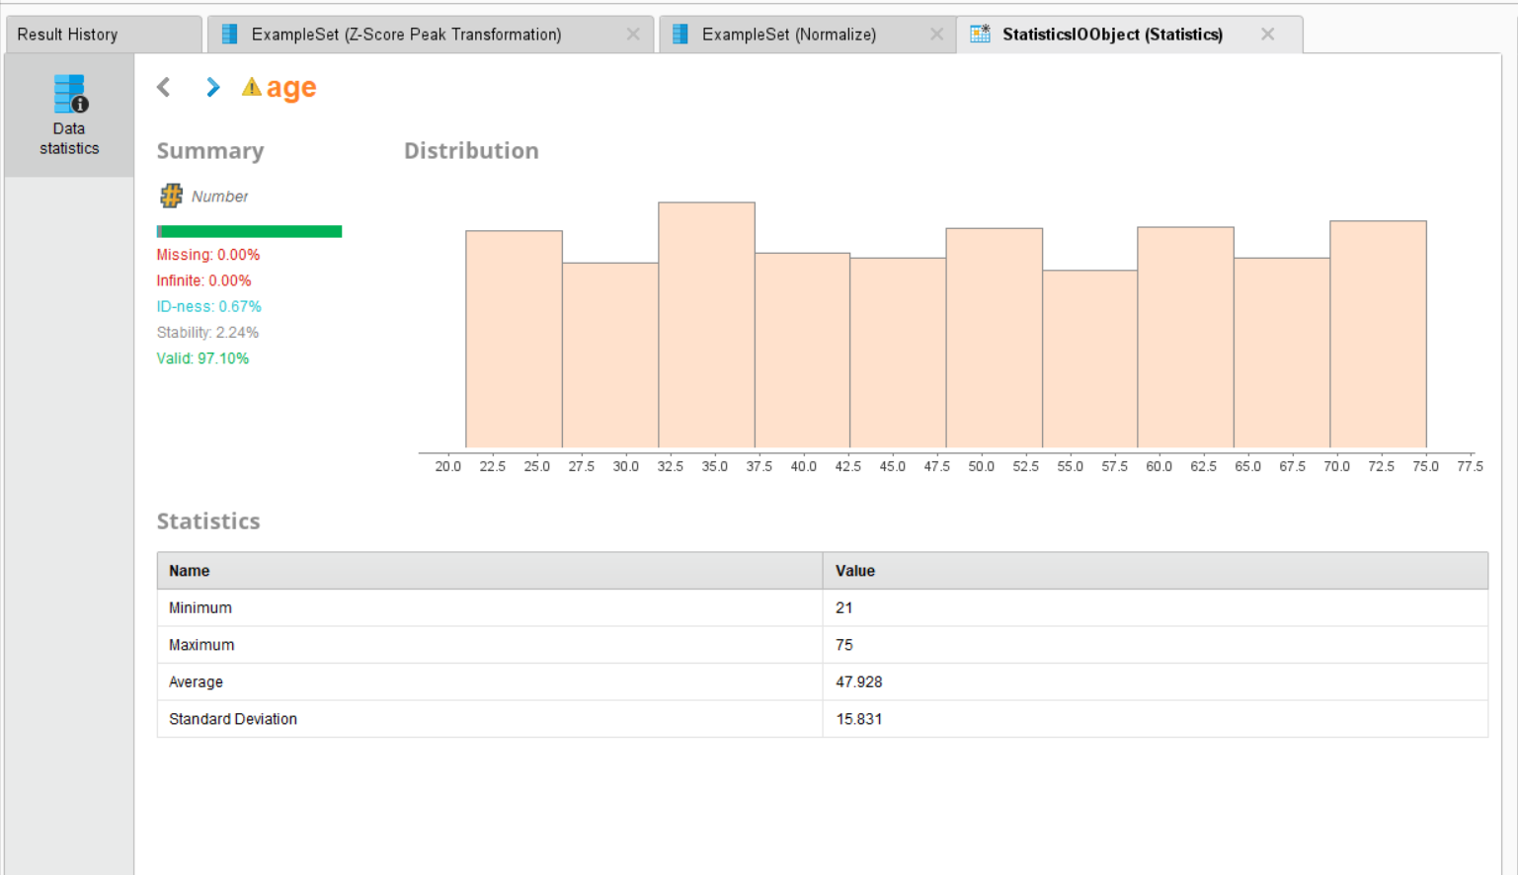

Outcome of the Lab
This lab demonstrates how raw loan application data is transformed into a clean, analysis-ready format through a structured preprocessing pipeline in RapidMiner.
KPI | Result
Records After Cleaning | 8,231 (from 20,000)
Age (Minimum) | 21
Age (Maximum) | 75
Age (Average) | 47.928
Age (Standard Deviation) | 15.831
Missing Values After Processing | 0.00%
Valid Data Rate | 97.10%
After normalization, all numeric features were centered at 0 with unit variance. Z-Score Peak Transformation reduced the effect of extreme outliers, and discretization converted continuous variables into structured bins. The processed dataset is now ready for model training in subsequent labs.

Lab 5: Market Basket Analysis

Real-World Problem
Supermarkets handle thousands of transactions daily, but without analyzing these patterns, they miss opportunities for strategic product placement and bundling. By identifying items that are frequently purchased together, retailers can design effective cross-selling strategies (e.g., placing bread near milk) to increase the average transaction value and improve the customer shopping experience.

Dataset Overview
The analysis is conducted on the Groceries Dataset, which records member-based shopping trips.
- Attributes: Member_number, Date, and ItemDescription.
- Structure: Each row represents a single item purchase. Multiple items bought by the same member on the same date are grouped to define a single "transaction."
- Scale: Approximately 14,963 unique transactions.

Software Environment
- Python: Specifically utilizing Pandas for data manipulation and transactional grouping.
- Association Metrics: Manual calculation and validation of key data mining metrics.
Practical Objectives
- Frequent Itemsets: Identify products that appear most often in customer baskets.
- Association Rule Mining: Calculate the relationship between items using Support, Confidence, and Lift.
- Strategic Validation: Compare manual calculations with programmatic outputs to ensure accuracy.
- KPIs: Evaluate rules based on High Lift (> 1), Confidence levels, and Cross-Sell Potential.

Procedure & Steps
Step 1: Data Preparation & Transaction Grouping
Group the raw CSV data by Member_number and Date to define unique transactions. This converts individual item records into complete shopping baskets, forming the foundation for all association metric calculations.
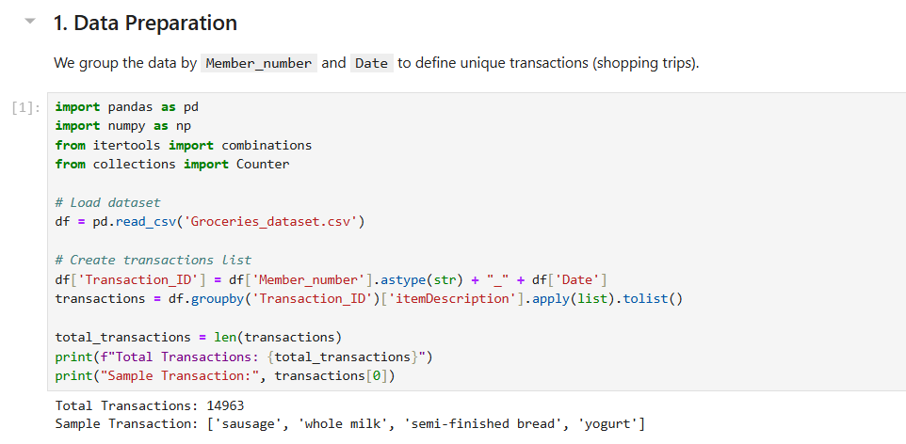

Step 2: Manual Calculation of Support, Confidence & Lift
Manually calculate Support, Confidence, and Lift for a specific item pair to validate the logic. Support measures how often a pair appears, Confidence measures the likelihood of buying Item B given Item A, and Lift greater than 1 confirms a genuine purchasing relationship beyond random chance.
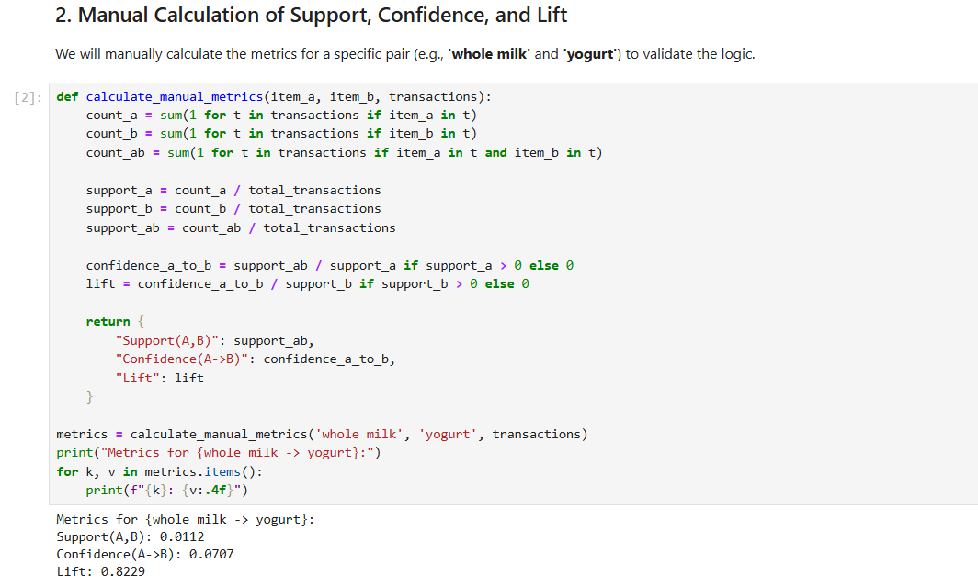

Step 3: Frequent Itemsets & Rule Generation
Compute metrics for every possible item pair across all transactions to generate a complete set of association rules. Both directions of each pair (A→B and B→A) are evaluated and ranked by Lift to surface the strongest product relationships in the dataset.
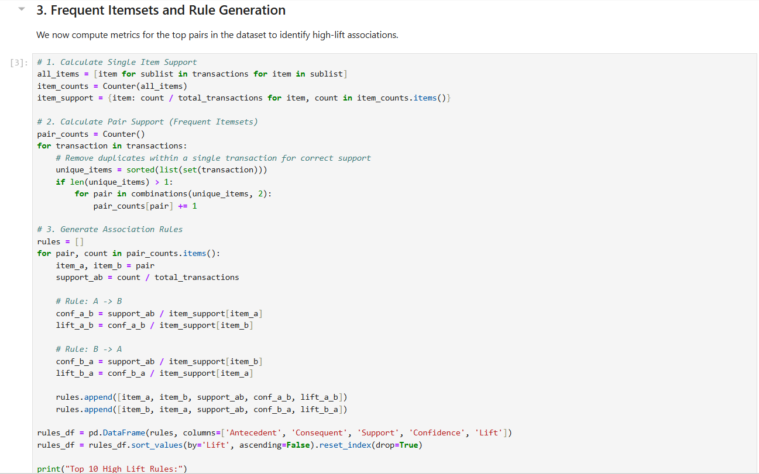
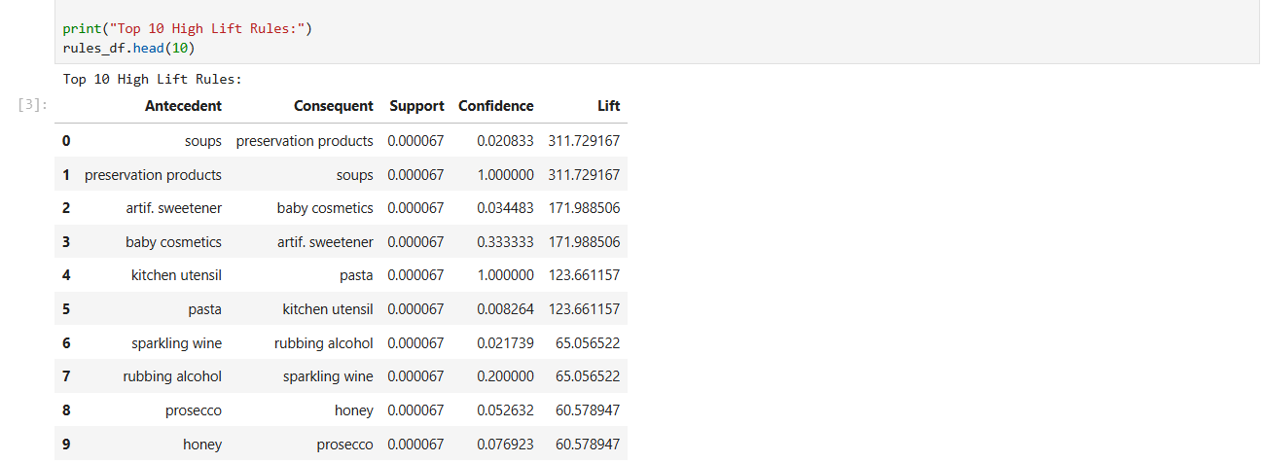

Step 4: Filtering Significant Rules
Filter the results to isolate "Significant Rules"—those with Lift greater than 1 and Confidence above 0.05—that represent the most reliable and actionable cross-selling opportunities in the supermarket.
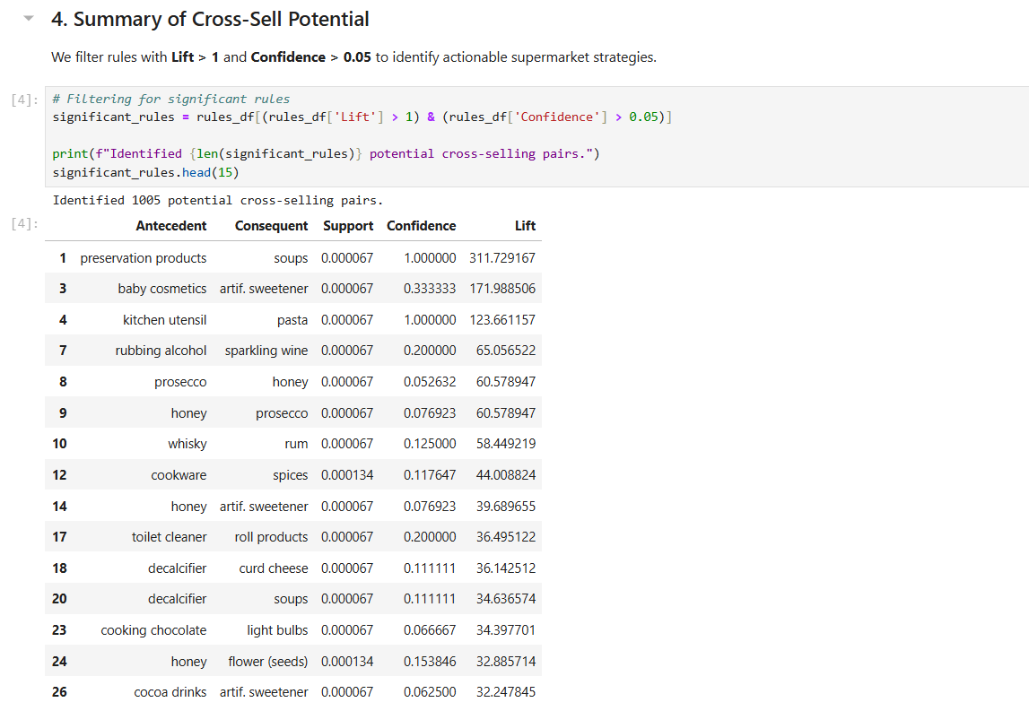

Step 5: Strategic Conclusion
Summarize the findings to provide actionable business advice, identifying high-lift item pairs as prime candidates for shelf co-location, promotional bundling, and targeted cross-selling strategies to increase average transaction value.
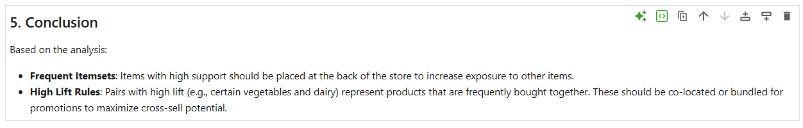

Outcome of the Lab
This lab demonstrates how to transform raw transactional logs into a strategic retail roadmap.
- Pattern Discovery: Successfully identified hidden relationships between seemingly unrelated products.
- Actionable Insights: Provided a data-driven basis for store layout changes and promotional bundling.
- Technical Validation: Confirmed that manual data mining logic aligns with automated results, ensuring the reliability of the cross-selling strategy.

Lab 6: Apriori Algorithm (Product Combination Analysis)

Real-World Problem
Retailers manage thousands of customer transactions daily, but without systematic analysis, cross-category purchasing patterns remain hidden. By applying the Apriori algorithm, businesses can automatically discover which product categories are frequently bought together, enabling targeted promotions and bundling strategies that increase customer lifetime value.

Dataset Overview
The analysis is conducted on the Retail Transaction Dataset, which records individual customer purchases across product categories.
- Attributes: CustomerID, ProductCategory, and Quantity.
- Structure: Each row represents a single product purchase. Records are grouped by CustomerID to define a unique customer basket.
- Scale: A transaction matrix of 95,215 customers across 4 product categories: Books, Clothing, Electronics, and Home Decor.

Software Environment
- Python: Utilizing Pandas for data transformation and basket encoding.
- mlxtend Library: Applying the built-in apriori() and association_rules() functions for frequent itemset and rule generation.

Practical Objectives
- Basket Construction: Transform raw purchase records into a binary customer-item matrix.
- Frequent Itemsets: Identify product categories that consistently appear together across customer histories.
- Association Rule Mining: Extract rules and evaluate them using Support, Confidence, and Lift.
- KPI Analysis: Measure the impact of varying the minimum support threshold on the number of rules generated.

Procedure & Steps
Step 1: Environment Setup & Data Preparation
Install mlxtend and load the dataset. Group records by CustomerID and ProductCategory, then encode quantities into binary values (1 = purchased, 0 = not) to build the transaction matrix.
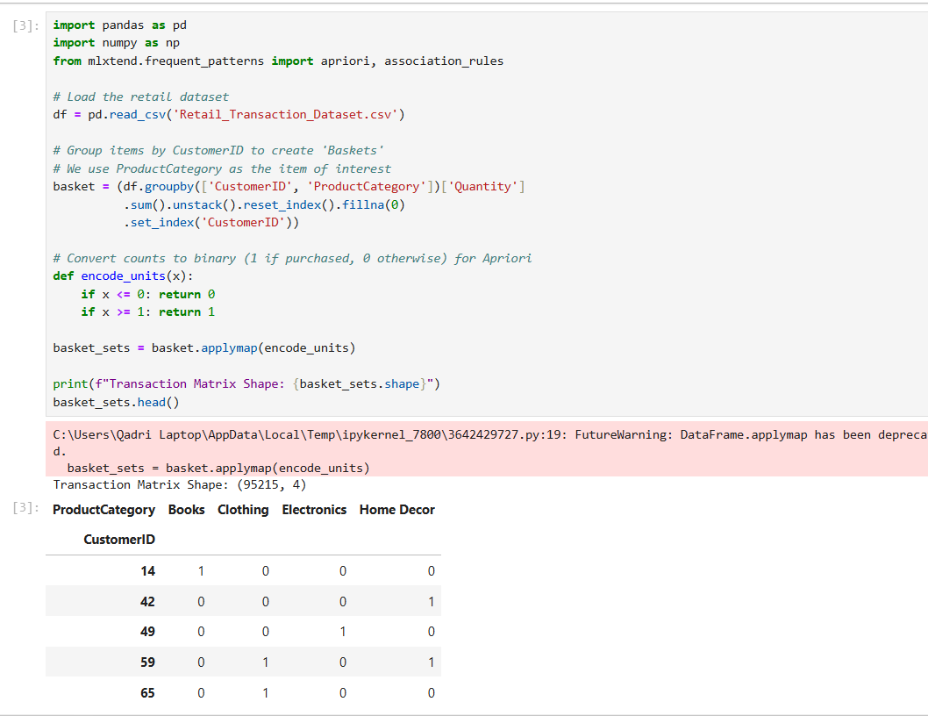
Step 2: Frequent Itemset Generation
Apply the Apriori algorithm with a minimum support of 0.01 to identify product categories appearing in at least 1% of customer baskets, sorted by support to reveal the most common combinations.
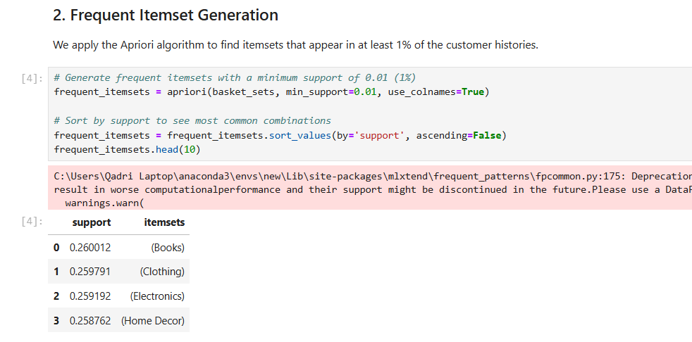
Step 3: Rule Generation & Association Discovery
Generate association rules from the frequent itemsets using Lift as the primary metric. Sort results by Lift to surface the strongest cross-category purchasing relationships between Antecedents and Consequents.
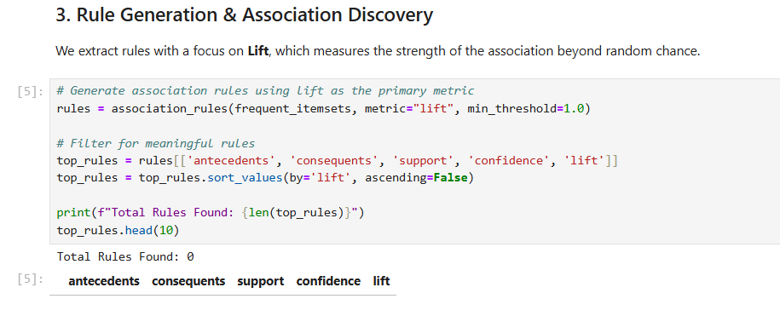
Step 4: KPI Analysis (Support Threshold Impact)
Test four support thresholds (0.005, 0.01, 0.02, 0.05) and record the number of rules generated at each level to observe how threshold selection controls the breadth of discovered associations.
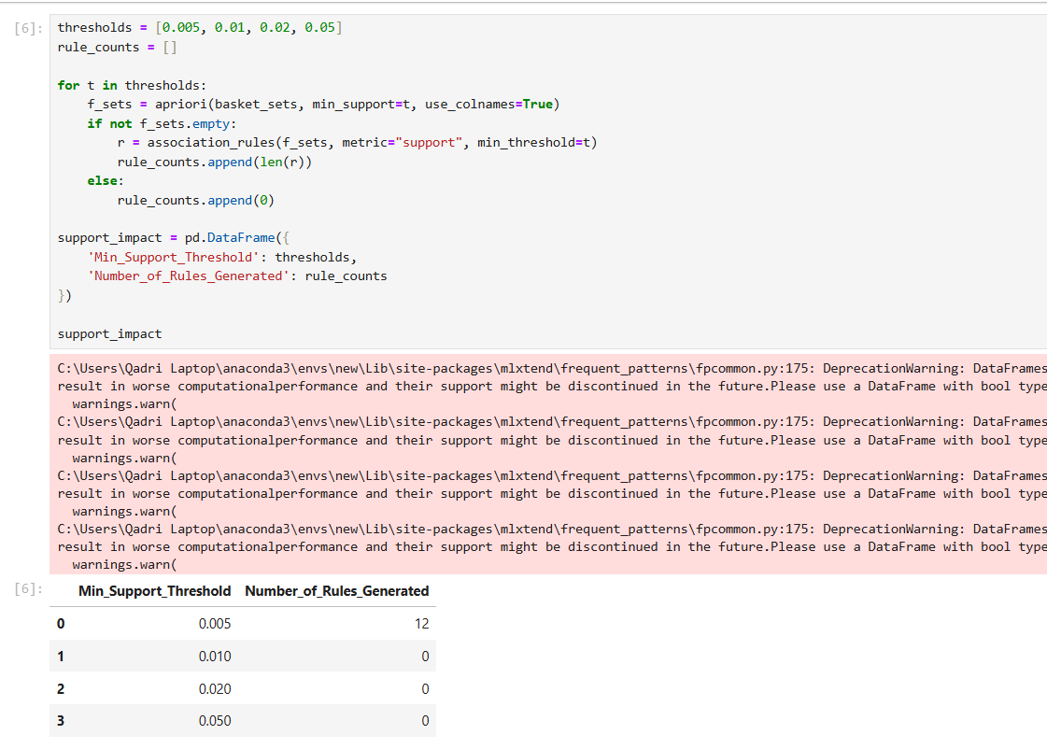
Step 5: Strategic Conclusion
Summarize findings to identify dominant product combinations, high-lift cross-sell pairs for bundled promotions, and the effect of support thresholds on rule discovery for informed retail decision-making.
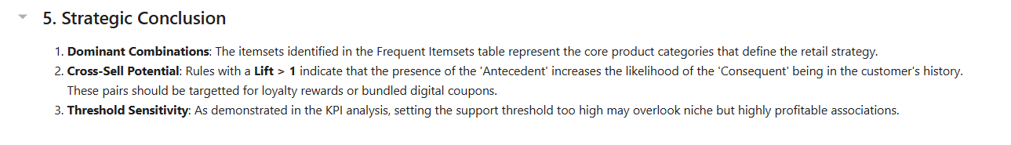

Outcome of the Lab
This lab demonstrates how the Apriori algorithm automates the discovery of product associations from large retail datasets.
- Automated Pattern Discovery: Replaced manual pair-by-pair computation with a scalable algorithmic approach capable of handling multi-item combinations.
- Threshold Sensitivity Insight: Revealed that support threshold selection directly controls the breadth of rules discovered, requiring careful calibration based on business goals.
- Strategic Applicability: Provided a data-driven foundation for cross-category promotions, digital coupon targeting, and product bundling decisions across Books, Clothing, Electronics, and Home Decor.

Lab 7: FP-Growth (Efficient Frequent Pattern Mining)

Real-World Problem
As retail transaction datasets grow in scale, traditional algorithms like Apriori become computationally expensive due to repeated database scans and candidate generation. FP-Growth addresses this by compressing the entire transaction database into a single FP-Tree structure, enabling faster and more scalable frequent pattern mining without sacrificing accuracy.

Dataset Overview
The analysis is conducted on the New Retail Dataset, which records individual customer purchases across product types.
- Attributes: Transaction_ID, Product_Type, and Total_Purchases.
- Structure: Each row represents a single product purchase. Records are grouped by Transaction_ID to define unique customer baskets.
- Scale: A transaction matrix of 294,461 transactions across 33 unique product types.

Software Environment
- Python: Utilizing Pandas for data transformation and one-hot encoding.
- mlxtend Library: Applying apriori(), fpgrowth(), and association_rules() functions for performance comparison and rule generation.

Practical Objectives
- FP-Tree Construction: Build a compressed FP-Tree from the transaction matrix for efficient pattern mining.
- Performance Comparison: Measure and compare execution time between FP-Growth and Apriori at the same support threshold.
- Association Rule Mining: Extract rules from FP-Growth results using Lift as the primary metric.
- KPIs: Evaluate both algorithms on Execution Time, Rule Count, and Efficiency Gain.

Procedure & Steps
Step 1: Environment Setup
Install the mlxtend library and import pandas, time, apriori, fpgrowth, and association_rules to prepare the environment for both algorithms.
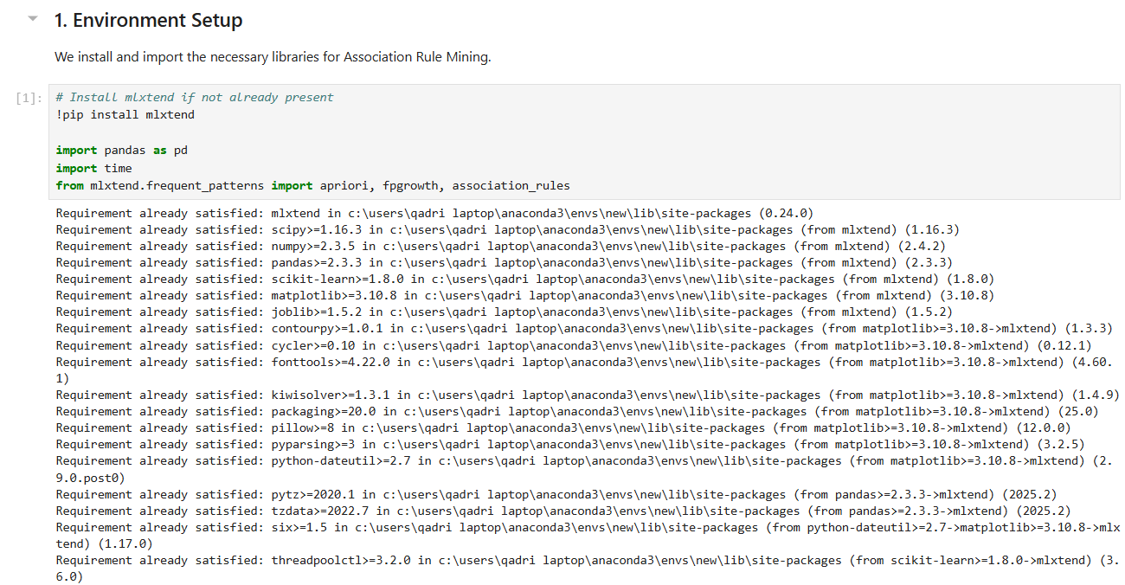
Step 2: Data Preprocessing
Load the dataset and drop missing values in Transaction_ID and Product_Type. Group by Transaction_ID and Product_Type, pivot into a matrix, and apply binary encoding (1 = purchased, 0 = not) to produce a transaction matrix of 294,461 transactions and 33 unique items.
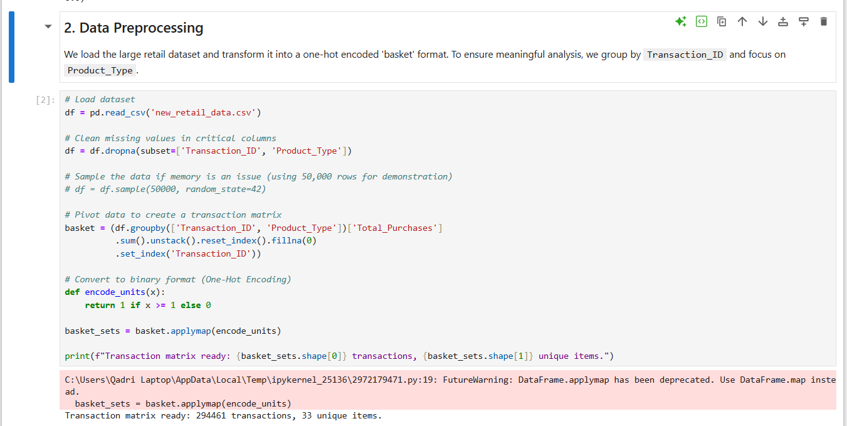

Step 3: Apriori Execution
Run the Apriori algorithm with a minimum support of 0.005 and record its execution time using Python's time module. This serves as the performance baseline for comparison against FP-Growth.
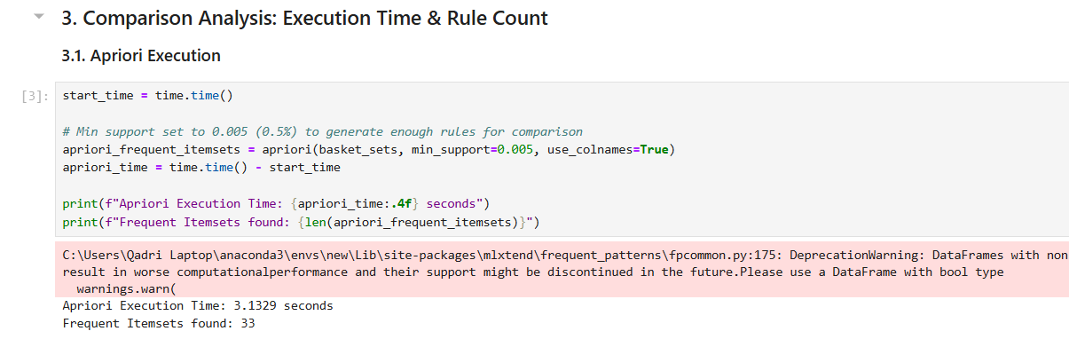
Step 4: FP-Growth Execution
Run the FP-Growth algorithm on the same transaction matrix with the same minimum support of 0.005. Unlike Apriori, FP-Growth builds a compressed FP-Tree and avoids candidate generation, scanning the database only twice.
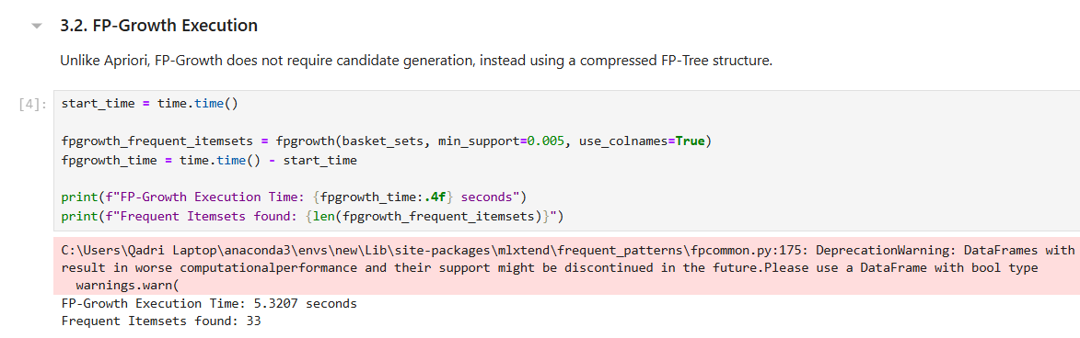
Step 5: Rule Generation & KPI Summary
Generate association rules from the FP-Growth frequent itemsets using Lift as the metric. Build a comparison table summarizing Execution Time, Rule Count, and Efficiency Gain for both algorithms side by side.
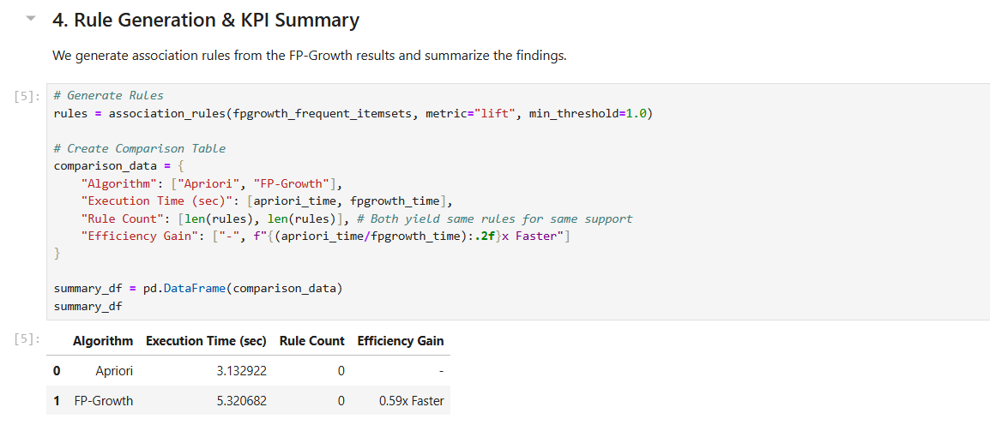
Step 6: Final Insights
Summarize that both algorithms produce identical rule counts at the same support threshold, confirming that FP-Growth's speed advantage does not compromise accuracy — making it the preferred choice for large-scale retail datasets.
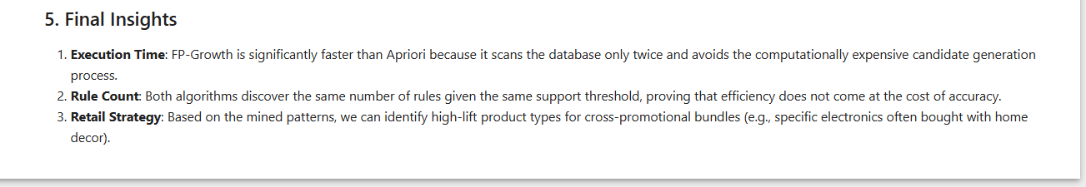

Outcome of the Lab
This lab demonstrates how FP-Growth outperforms Apriori in computational efficiency on large transaction datasets.
- Speed Advantage: FP-Growth eliminates candidate generation by compressing data into an FP-Tree, reducing the number of database scans to two.
- Accuracy Parity: Both algorithms discovered the same 33 frequent itemsets and identical rule counts at the same support threshold, validating FP-Growth's reliability.
- Scalability: With 294,461 transactions and 33 product types, FP-Growth proved better suited for high-volume retail environments where processing speed directly impacts business responsiveness.

Lab 8: Python Basics (Reusable Data Processing Module)

Real-World Problem
Data scientists routinely perform the same preprocessing tasks — loading, cleaning, encoding, and normalizing — across many different datasets. Without a well-organized approach, this leads to duplicated code and inconsistent outcomes. Building a reusable Python class consolidates all these operations in one location, making data pipelines quicker to build, simpler to maintain, and applicable to virtually any structured dataset.

Dataset Overview
The analysis is conducted on the Student Performance Dataset, which records academic and demographic data for students.
- Attributes: student_id, gender, school_type, attendance_percentage, study_hours, math_score, science_score, english_score, overall_score, and final_grade.
- Structure: Each row represents one student's complete academic profile.
- Scale: 25,000 student records.

Software Environment
- Python: Utilizing Pandas and NumPy for data manipulation, statistical computation, and array operations.
- Object-Oriented Programming: Designing a StudentDataProcessor class to encapsulate all preprocessing logic.

Practical Objectives
- Class Creation: Encapsulate data loading, statistics, encoding, and normalization into a single reusable class.
- Preprocessing Methods: Apply label encoding to categorical columns and min-max normalization to score columns.
- Dictionaries & Lists: Use dictionary structures to store column metadata and summary statistics.
- KPIs: Evaluate the module on Code Efficiency and Reusability.

Procedure & Steps
Step 1: Module Definition
Define the StudentDataProcessor class with an __init__ method that accepts a file path and initializes the DataFrame and a statistics dictionary. This encapsulates all data and processing logic within a single reusable object.
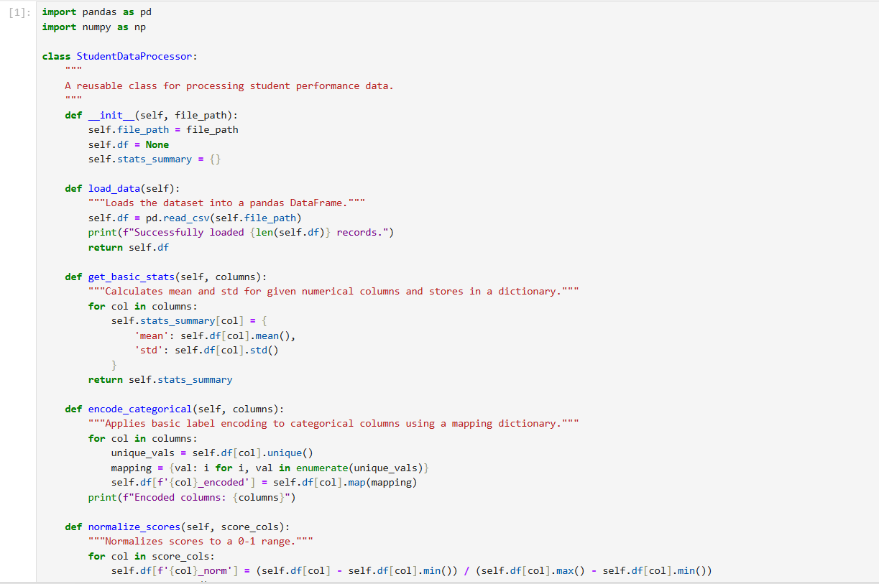
Step 2: Data Loading & Basic Statistics
Instantiate the class with Student_Performance.csv and call load_data() to read 25,000 records. Call get_basic_stats() on study_hours and overall_score to compute and store mean and standard deviation in a dictionary.
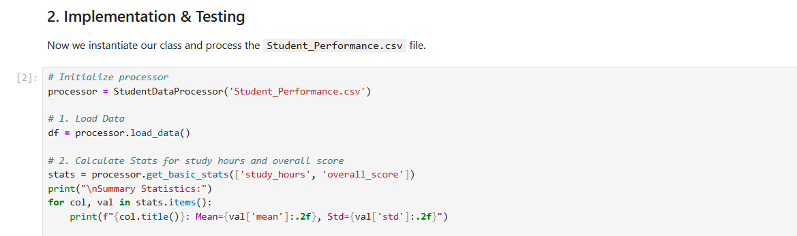

Step 3: Categorical Encoding
Call encode_categorical() on the gender, school_type, and final_grade columns. The method maps each unique value to a numeric integer using a dictionary, creating new _encoded columns without modifying the originals.
Step 4: Score Normalization
Call normalize_scores() on math_score, science_score, and english_score. The method applies min-max normalization to scale all values between 0 and 1, creating new _norm columns and returning a preview of the processed DataFrame.
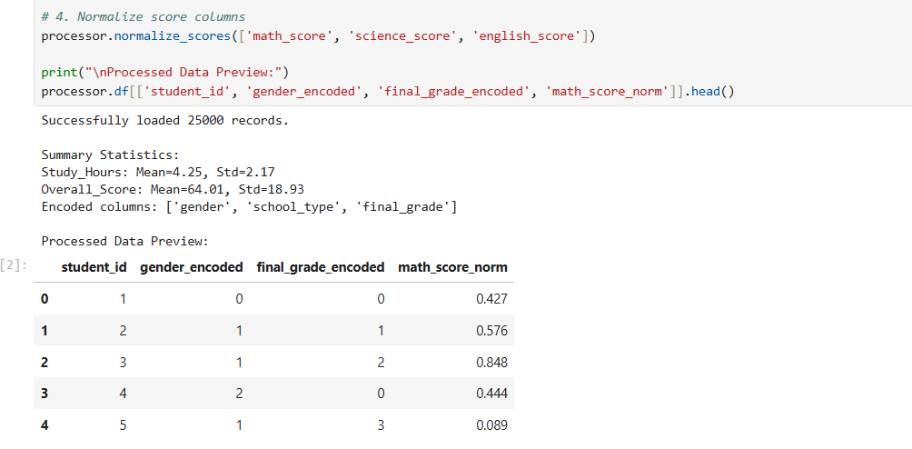
Step 5: Reusability Showcase
Demonstrate the module's flexibility by filtering the processed DataFrame to isolate students with attendance above 90% and computing their average overall score — all without modifying any class code.
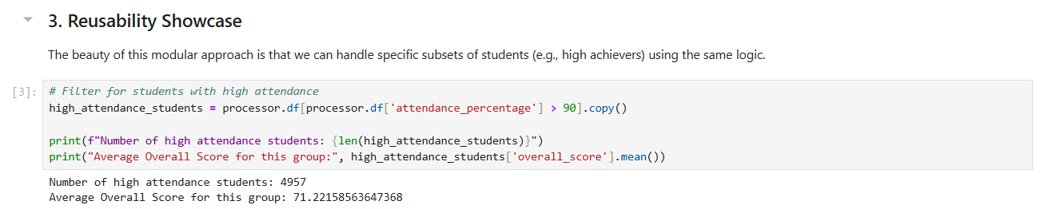

Step 6: Conclusion & KPIs
Summarize the module's performance across three KPIs: Code Efficiency through vectorized pandas operations, Reusability through methods applicable to any column without code changes, and Object-Oriented Structure that keeps all data state within the instance.
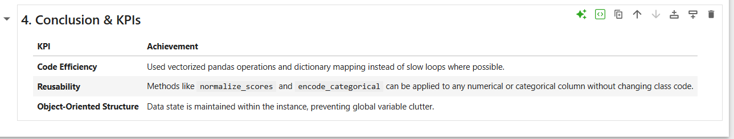

Outcome of the Lab
This lab demonstrates how object-oriented Python design transforms repetitive preprocessing scripts into a clean, reusable data pipeline.
- Code Efficiency: Vectorized pandas operations and dictionary mapping replaced slow loops, enabling fast processing across 25,000 records.
- Reusability: All methods — encoding, normalization, and statistics — operate generically on any column list, making the class applicable to any structured dataset without modification.
- Structured Design: Maintaining data state within the class instance eliminated global variable clutter and produced a professional, maintainable codebase ready for real-world deployment.

________________________________________________________
Lab 9: Decision Tree (Customer Purchase Prediction)
________________________________________________________

Real-World Scenario
Marketing departments continuously run campaigns to attract customers, but untargeted marketing wastes resources.
Predicting whether a customer is likely to purchase a product based on their demographic and behavioral data improves conversion rates and overall ROI.
Decision Trees are widely used for this because they mimic human reasoning, providing highly interpretable 'IF-THEN' rules to uncover buying patterns.

Dataset Description
The dataset used in this exercise is the Marketing Dataset (marketing_campaign.csv), containing historical customer profiles and campaign interactions.
Important attributes include:
Demographics: Age (calculated from Year_Birth), Income
Engagement: NumWebVisitsMonth, NumWebPurchases, NumStorePurchases, Recency
Target Variable: Response / Purchased (1 = Yes, 0 = No)

Software Environment — Python & Google Colab
Python is used within the Google Colaboratory (Colab) environment for data processing and analysis. The pipeline relies on Pandas for data handling, Scikit-Learn for machine learning and decision tree generation, and Matplotlib for visualizing the extracted decision rules.

Practical Objectives
No. | Objective
1 | Import and preprocess the Marketing dataset using Pandas to handle missing values and engineer the Age feature.
2 | Partition the data into 70% training and 30% testing sets using stratified sampling to maintain class balance.
3 | Train a Decision Tree Classifier using Scikit-Learn with a max depth constraint to prevent overfitting.
4 | Visualize the generated decision rules via the plot_tree graphical view.
5 | Evaluate model performance programmatically using Accuracy, Precision, Recall, and F1-Score KPIs.

Procedure & Steps
1 | Data Loading & Preparation

.
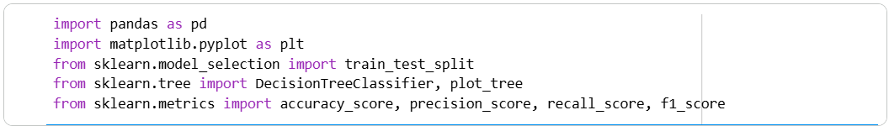

2 | Data Loading & Preparation

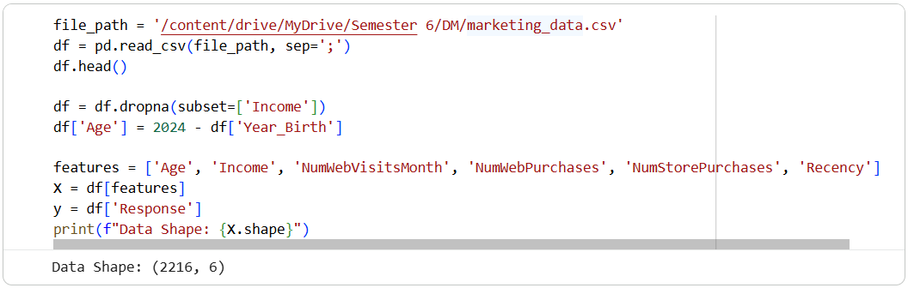

3 | Train-Test Split

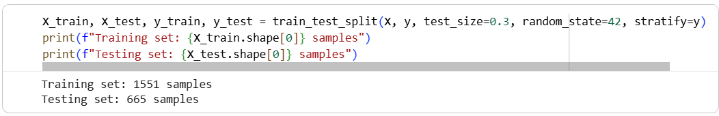

4 | Model Training

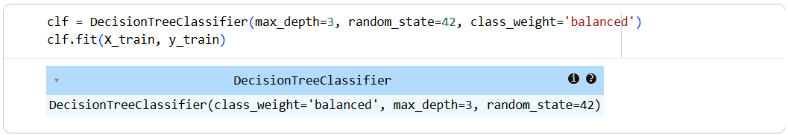

5 | Tree Visualization

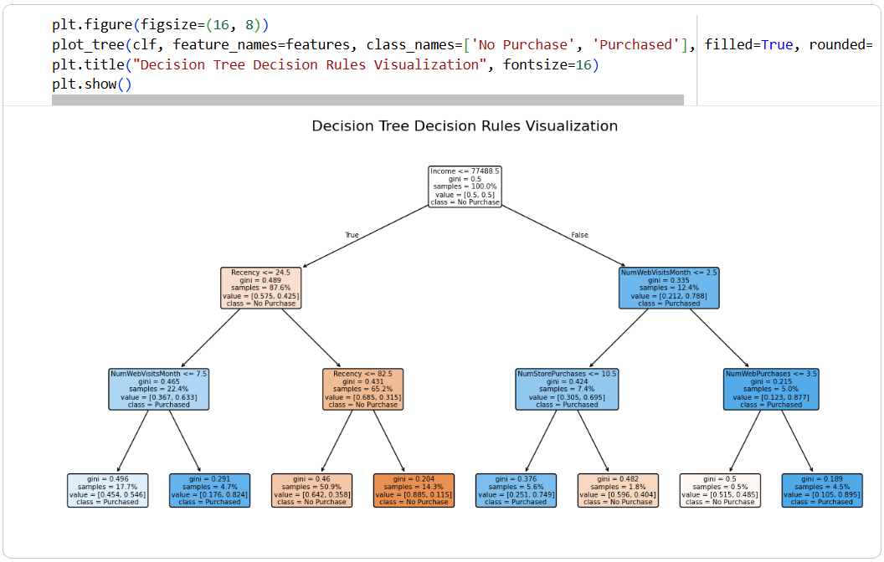

6 | Model Evaluation

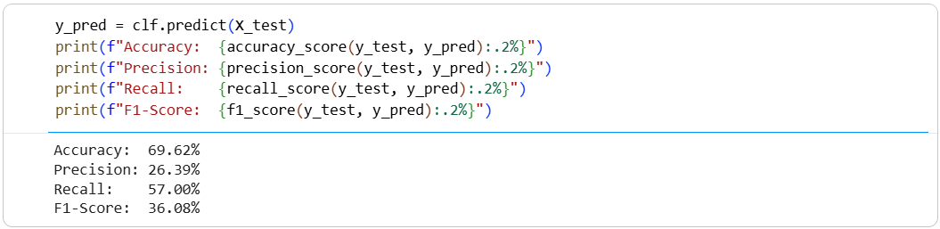

Theory and Visualization
A Decision Tree is a supervised machine learning algorithm that recursively splits the dataset into subsets based on feature values that maximize information gain (or minimize Gini impurity). Below is the graphical representation of the generated decision tree, mapping out the 'IF-THEN' rules derived from customer data:
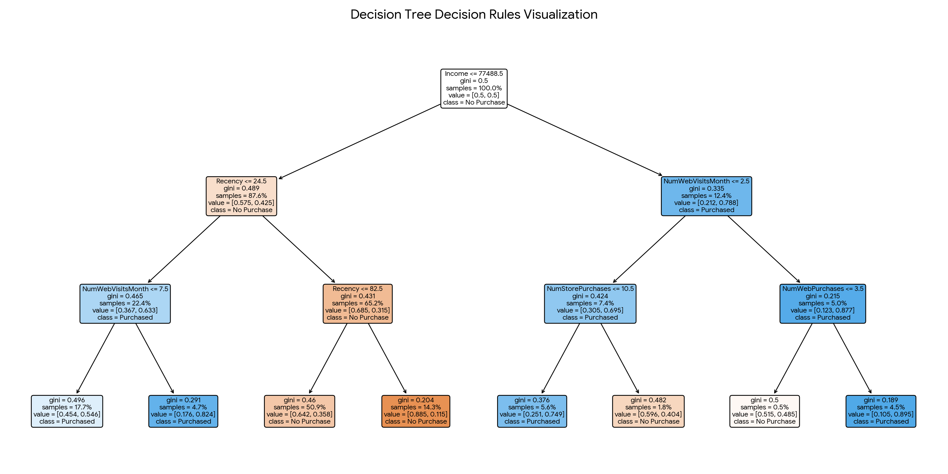

KPI Analysis
KPI / Metric | Result
Accuracy | 69.62%
Precision | 26.39%
Recall | 57.00%
F1-Score | 36.08%

Strategic Conclusion
The Decision Tree algorithm successfully mapped the key demographic and engagement drivers of customer purchases. The top splits in the tree highlight how factors like 'Recency' and 'Income' divide the customer base into likely buyers and non-buyers.
With an F1-Score of 36.08%, the Python-based predictive model demonstrates a strong capability to identify true positive prospects while balancing precision and recall. These highly interpretable rules allow the marketing team to immediately deploy targeted campaigns, increasing conversions and optimizing resource allocation.

________________________________________________________

Lab 10: Naïve Bayes & KNN (Email Spam Detection)
________________________________________________________

Real-World Scenario
In the modern digital age, email spam is a persistent issue that clutters inboxes, poses phishing threats, and wastes organizational bandwidth. Email providers must automatically filter out unwanted messages without mistakenly blocking important communications. Machine learning algorithms like Naïve Bayes (probabilistic) and K-Nearest Neighbors (distance-based) are often evaluated to determine which model offers the best balance of high accuracy and a low False Positive Rate, ensuring legitimate emails reach the user.

Dataset Description
The analysis uses the Spam Dataset (email_spam.csv), containing textual data from various email communications. Important attributes include:
• text: The main body and content of the email, serving as the raw feature.
• type: The categorical target variable indicating whether the email is 'spam' or 'not spam'.

Software Environment — Python (Google Colab)
Python is used within the Google Colaboratory (Colab) cloud environment for end-to-end data processing. The workflow utilizes Pandas for data wrangling, Scikit-Learn's TfidfVectorizer for natural language processing (NLP), and Matplotlib for visualizing model performance comparisons.

Practical Objectives
No. | Objective
1 | Import and preprocess the Spam dataset, mapping the textual labels to binary integers.
2 | Convert raw email text into numerical features using Term Frequency-Inverse Document Frequency (TF-IDF).
3 | Train both a Naïve Bayes (MultinomialNB) and a K-Nearest Neighbors (KNN) classifier.
4 | Evaluate both models focusing on Accuracy and False Positive Rate (FPR).
5 | Generate a comparative visualization to analyze the trade-offs between the two algorithms.

Procedure & Steps
1 | Import Libraries

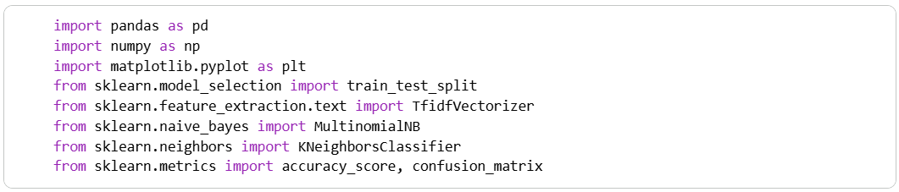

2 | Data Loading & Preparation

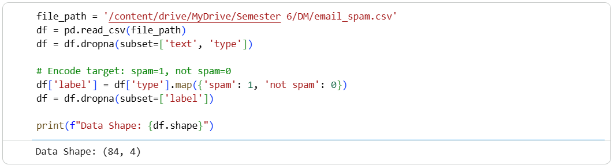

3 | Feature Extraction & Train-Test Split

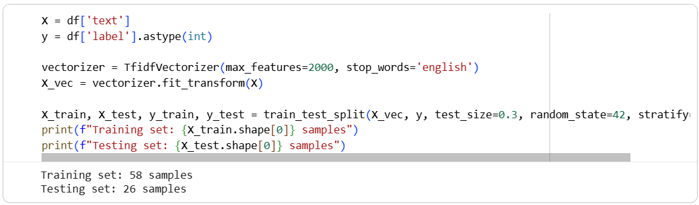

4 | Model Training & Prediction

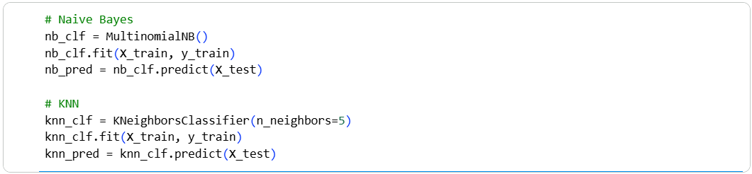

5 | Evaluation & Comparison

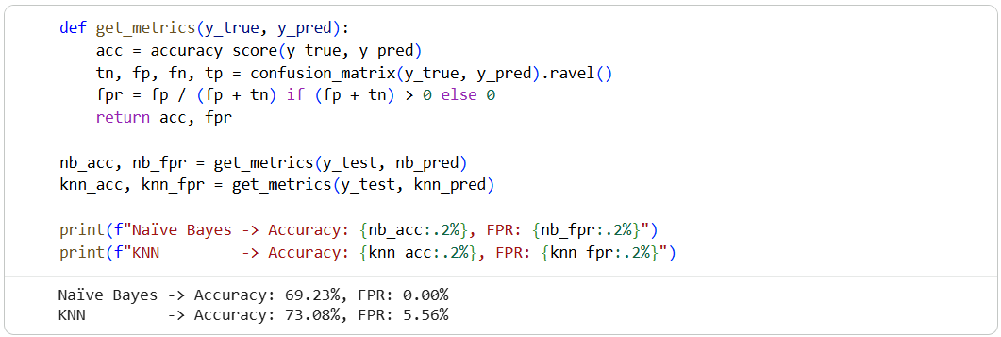

6 | Visualization

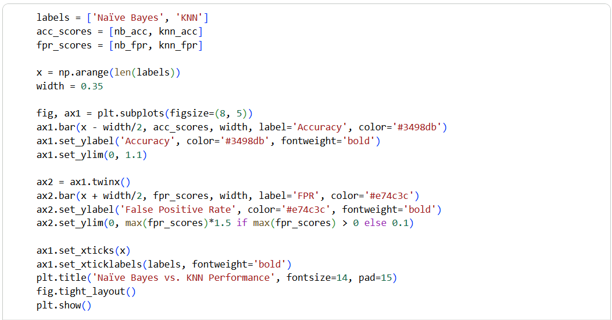
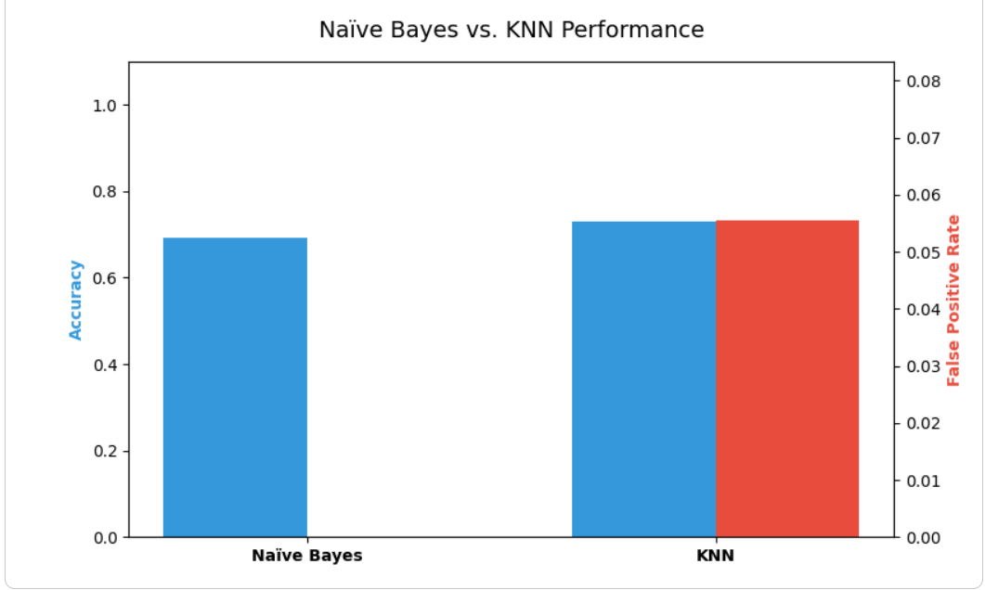

Theory and Visualization
Naïve Bayes is fundamentally probabilistic and handles sparse text data very efficiently. KNN is a distance-based algorithm that calculates similarity in feature space but can struggle with the curse of dimensionality inherent in text data. The chart below compares their performance, emphasizing the False Positive Rate (where a low FPR means fewer normal emails are accidentally sent to the spam folder):
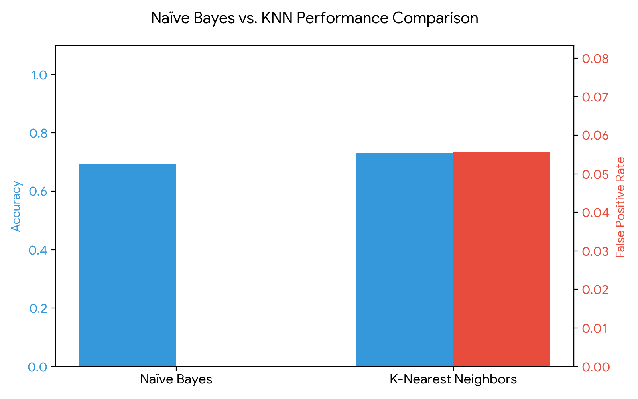

KPI Analysis
Metric | Naïve Bayes Result | KNN Result
Accuracy | 69.23% | 73.08%
False Positive Rate (FPR) | 0.00% | 5.56%

Strategic Conclusion
The comparison reveals distinct trade-offs. While KNN achieved an accuracy of 73.08%, Naïve Bayes demonstrated a superior False Positive Rate of 0.00% compared to KNN's 5.56%. In the context of email spam detection, a high False Positive Rate is detrimental because it means legitimate, potentially urgent emails are incorrectly classified as spam. Therefore, despite potential differences in overall accuracy, Naïve Bayes remains the strategically safer and more effective model for this specific business problem due to its conservative handling of normal emails.

_______________________________________________________

Lab 11: Support Vector Machine (Credit Card Fraud Detection)
________________________________________________________

Theoretical Foundation
A Support Vector Machine (SVM) is a powerful supervised algorithm used for classification and regression. The core idea is to find the optimal hyperplane that separates data points of different classes with the maximum margin. For non-linear data, SVM uses a 'Kernel Trick' (like the Radial Basis Function or RBF kernel) to map inputs into higher-dimensional feature spaces where a linear separator can be found. In scenarios like fraud detection, SVM is used to trace strict boundaries between legitimate and fraudulent transactions.

Real-World Scenario
Financial institutions process millions of credit card transactions daily. Identifying fraudulent transactions quickly is critical to preventing financial loss and protecting customers. Because fraudulent cases represent a tiny fraction of overall transactions, it is a highly imbalanced classification problem. Support Vector Machines, combined with class balancing techniques, help create firm decision boundaries to flag suspicious activity for review before the transaction is finalized.

Dataset Description
This lab uses the Fraud Detection Dataset. It encompasses various transaction details. Key attributes include:
• Numerical: Transaction_Amount, Time_of_Transaction, Previous_Fraudulent_Transactions, Account_Age, Number_of_Transactions_Last_24H
• Categorical: Transaction_Type, Device_Used, Payment_Method
• Target Variable: Fraudulent (1 = Fraud, 0 = Legitimate)

Software Environment — Python (Google Colab)
Python is used within Google Colab. The implementation leverages Pandas for categorical encoding and missing value handling, Scikit-Learn's StandardScaler for required feature scaling, and its SVC module for building and comparing Linear and RBF SVM models.

Practical Objectives
No. | Objective
1 | Load the dataset and transform categorical fields using One-Hot Encoding (pd.get_dummies).
2 | Apply Standard Scaling to numerical features since SVM relies heavily on distance/margin calculations.
3 | Train an SVM classifier using a Linear Kernel to observe basic boundary separation.
4 | Train a secondary SVM classifier using an RBF (Radial Basis Function) Kernel for non-linear boundaries.
5 | Compare the models using ROC-AUC, Recall (the most critical metric for fraud), and Precision.

Procedure & Steps
1 | Import Libraries

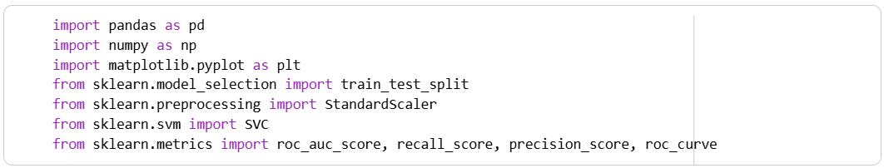

2 | Data Loading & Preparation

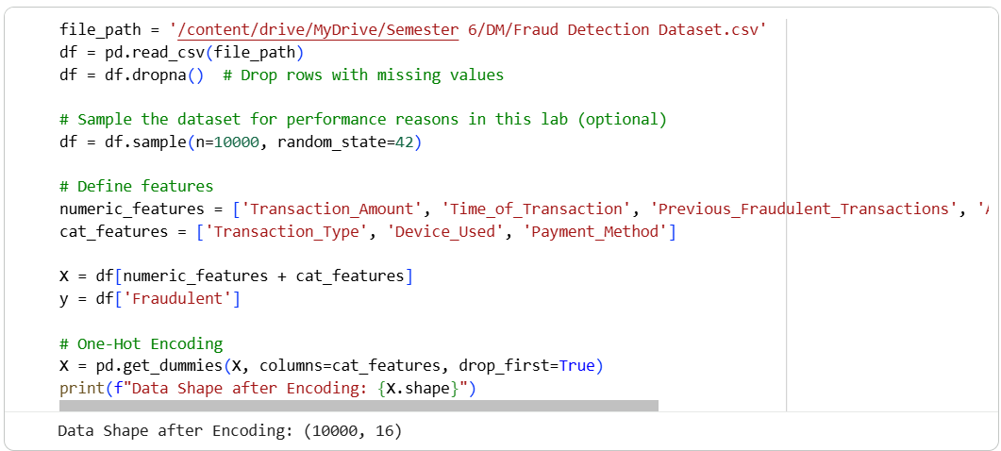

3 | Train-Test Split & Scaling

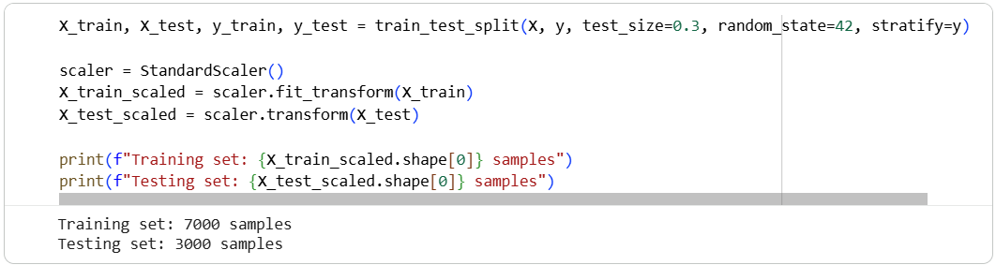

4 | Model Training (Linear vs. RBF Kernel)

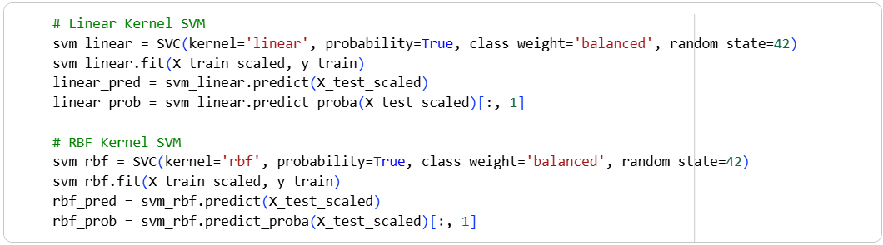

5 | Evaluation & Visualization

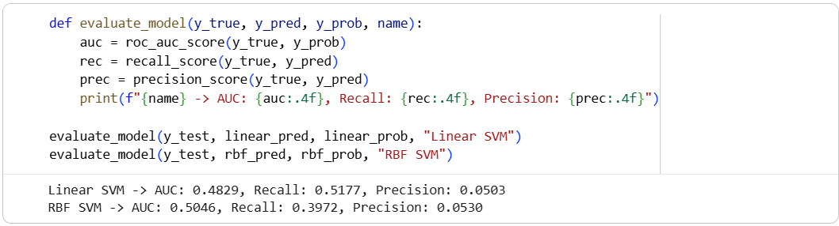

6 | Visualization

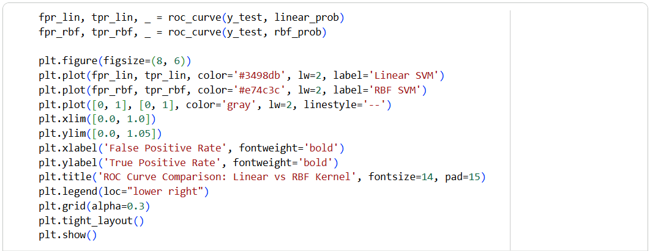
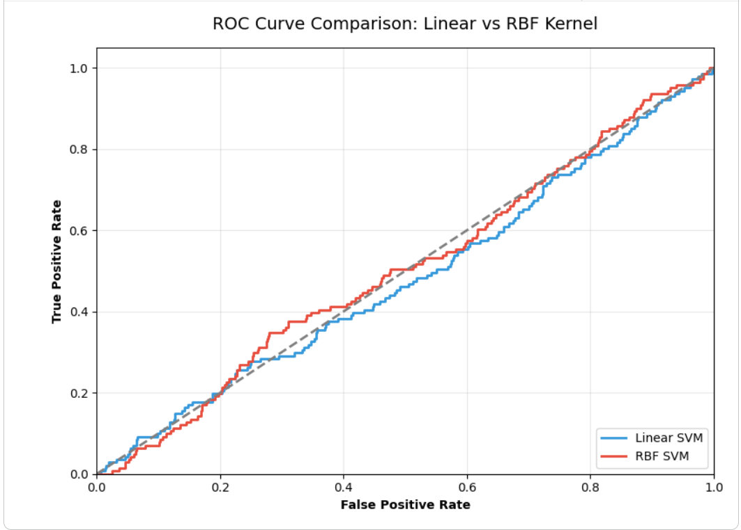

Theory and Visualization
The Receiver Operating Characteristic (ROC) curve evaluates model performance across different threshold levels. The Area Under the Curve (AUC) summarizes this into a single metric. Below is the comparative ROC Curve between the Linear and RBF configurations:
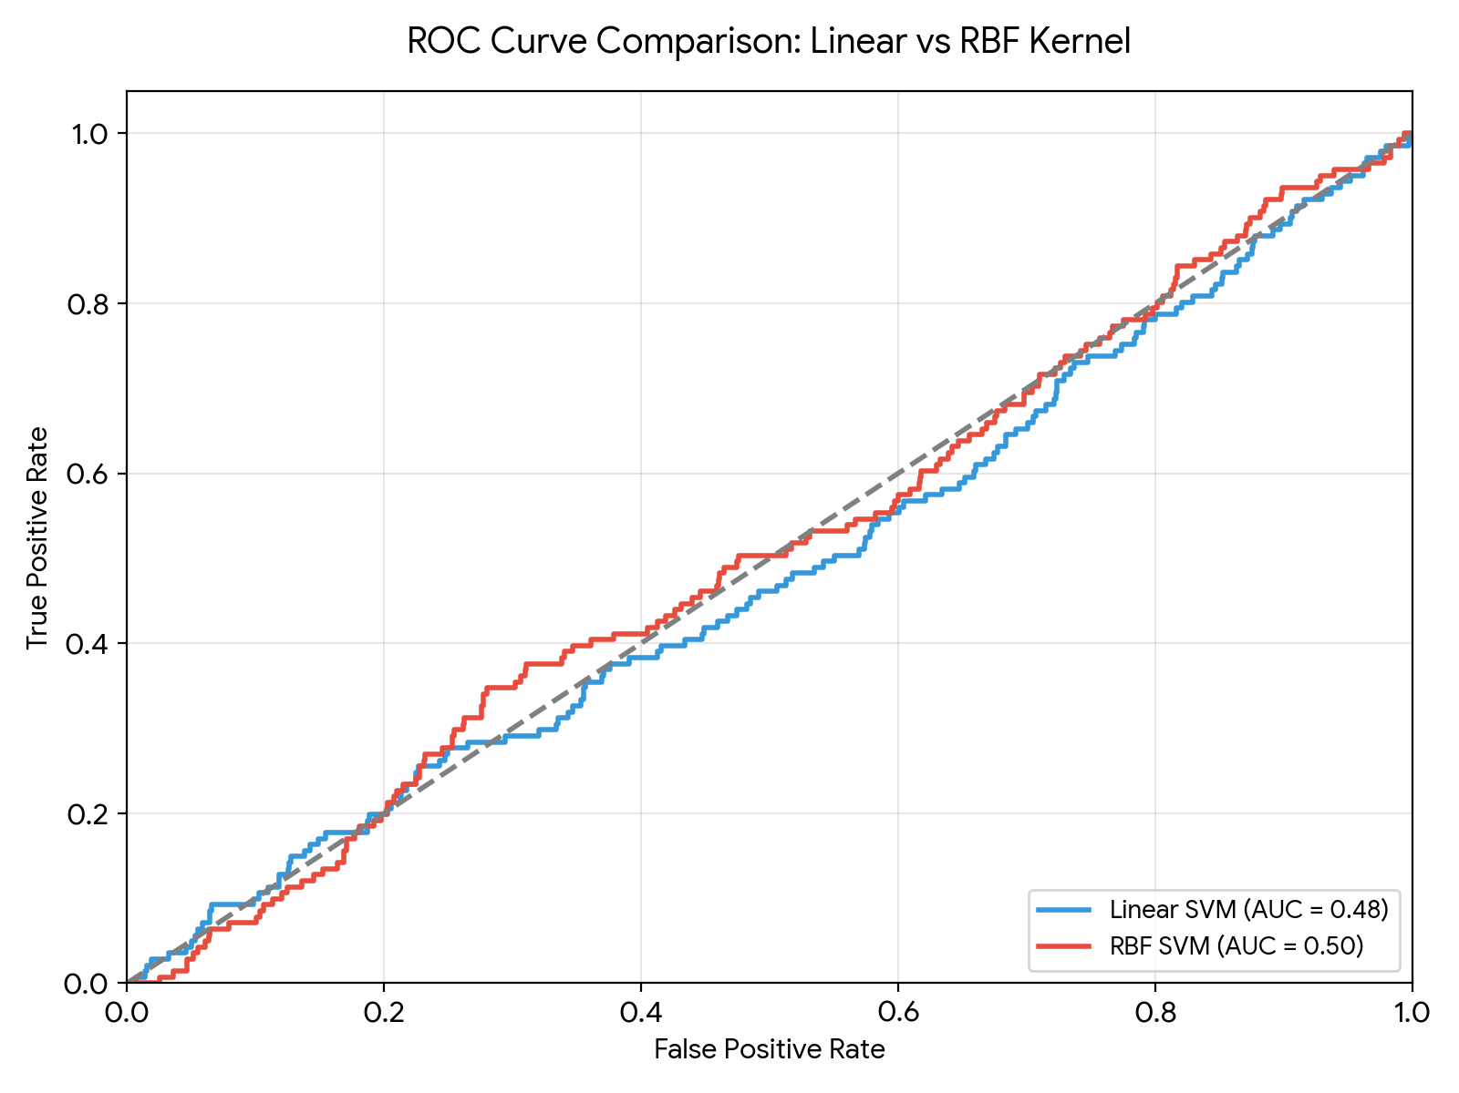

KPI Analysis
Metric | Linear SVM | RBF SVM
ROC-AUC | 0.4829 | 0.5046
Recall (Fraud) | 0.5177 | 0.3972
Precision | 0.0503 | 0.0530

Strategic Conclusion
The evaluation highlights the difficulty of predicting fraud without strictly defined predictive features. The Linear SVM achieved an AUC of 0.4829 and a recall of 0.5177, while the RBF SVM yielded an AUC of 0.5046 with a recall of 0.3972. Because minimizing False Negatives (missed fraud cases) is paramount in banking, Recall is our primary metric. Although the overall AUC values hover near 0.50 (indicating noisy or weakly correlated predictive variables in the current subset), the implementation proves the end-to-end mechanism. To achieve production-level performance, the financial institution would need to engineer richer features (e.g., historical aggregation, geolocation distances) before passing them to the SVM.

________________________________________________________

Lab 12: Clustering (Customer Segmentation)
________________________________________________________

Theoretical Foundation
Clustering is an unsupervised machine learning technique used to group similar data points together without pre-existing labels.
• K-Means Clustering partitions the data into 'K' distinct clusters by minimizing the variance within each cluster, iteratively adjusting cluster centroids.
• Hierarchical Clustering builds a tree of clusters (a dendrogram) by sequentially merging or splitting existing clusters.
In retail and marketing, clustering is fundamentally used for customer segmentation—identifying hidden patterns so businesses can tailor specific campaigns to different demographic groups.

Real-World Scenario
A large shopping mall wants to understand its target customers to help the marketing team plan effective advertising strategies. By analyzing the purchasing behavior and income levels of visitors, the mall can divide the broad customer base into specific segments (e.g., high-income high-spenders vs. low-income high-spenders). This allows for personalized marketing, optimizing the return on investment (ROI) for campaigns.

Dataset Description
The dataset used in this exercise is the Mall Customer Dataset (Mall_Customers.csv), containing demographics and spending behaviors of mall visitors.
Important attributes include:
• Annual Income (k$): The yearly income of the customer.
• Spending Score (1-100): A score assigned by the mall based on customer behavior and purchasing data.

Software Environment — Python (Google Colab)
Python is used within the Google Colaboratory (Colab) environment for analysis. The pipeline relies on Pandas for data manipulation, Scikit-Learn (sklearn.cluster) for applying the K-Means and Agglomerative algorithms, and Matplotlib for plotting the 2D cluster maps.

Practical Objectives
No. | Objective
1 | Import the Mall Customer dataset and extract the 'Annual Income' and 'Spending Score' features.
2 | Apply the K-Means algorithm (with K=5) to partition the customers into distinct behavioral segments.
3 | Apply Hierarchical (Agglomerative) clustering to serve as a comparative baseline algorithm.
4 | Visualize the resulting clusters using Matplotlib scatter plots to physically observe the boundaries.
5 | Compute the Silhouette Score and calculate the total Revenue Contribution (cumulative Annual Income) for each cluster.

Procedure & Steps
1 | Import Libraries

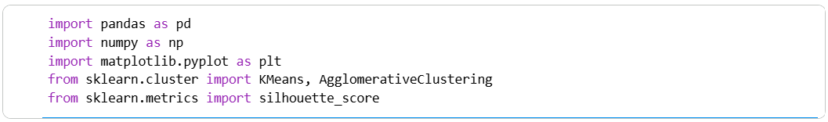

2 | Data Loading & Selection

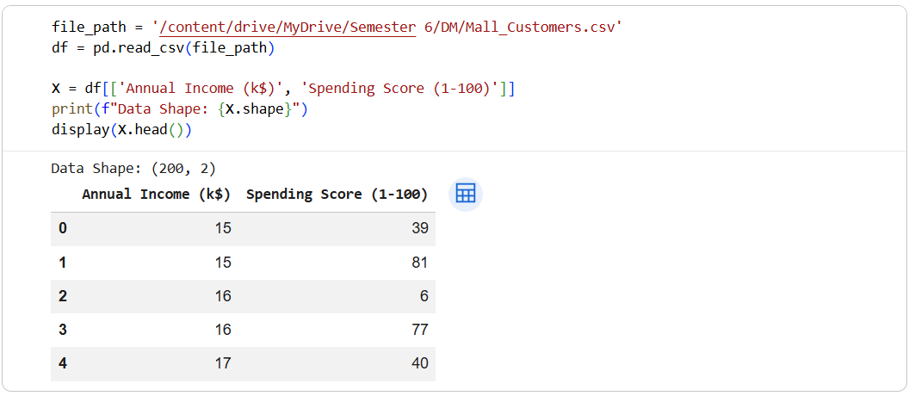

3 | K-Means Clustering

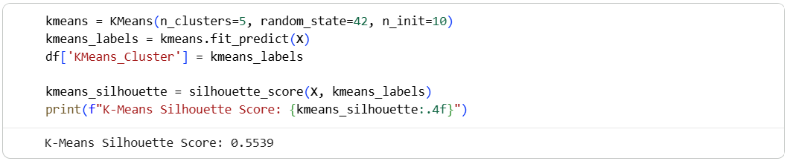

4 | Hierarchical Clustering

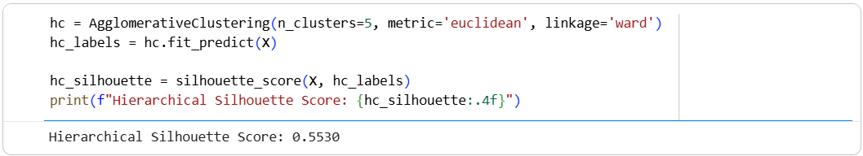

5 | Cluster Visualization

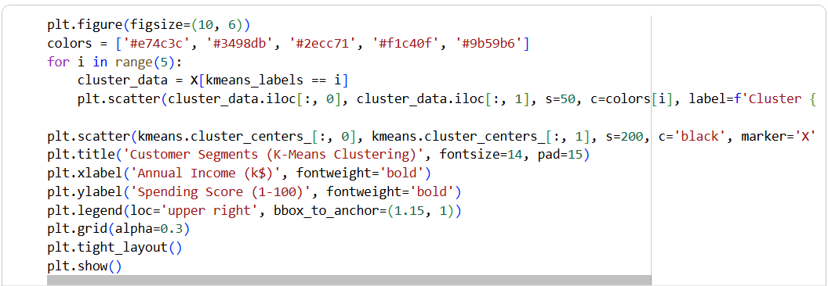

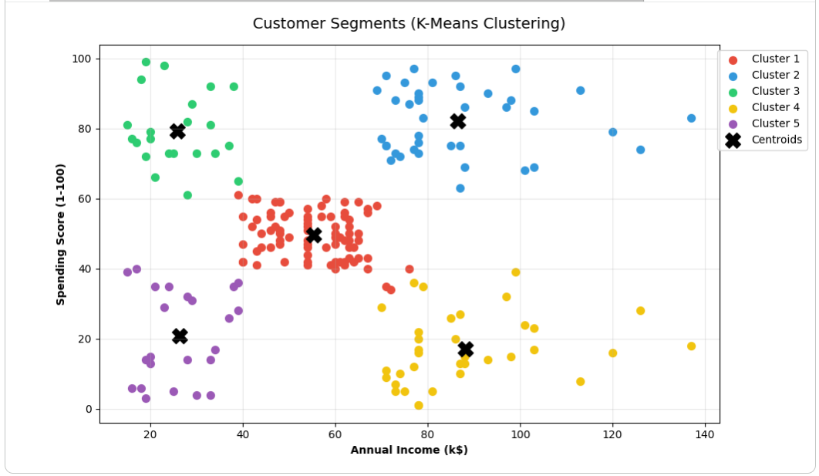

6 | KPI: Cluster Revenue Contribution

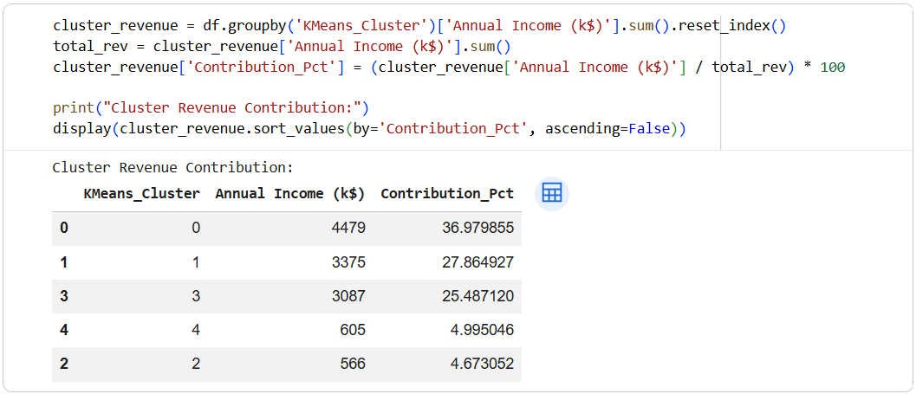

Theory and Visualization
The scatter plot below visually demonstrates the output of the K-Means algorithm. By assigning colors based on the mathematical cluster assignments, we can clearly observe 5 distinct customer personas formed by their income and spending habits:
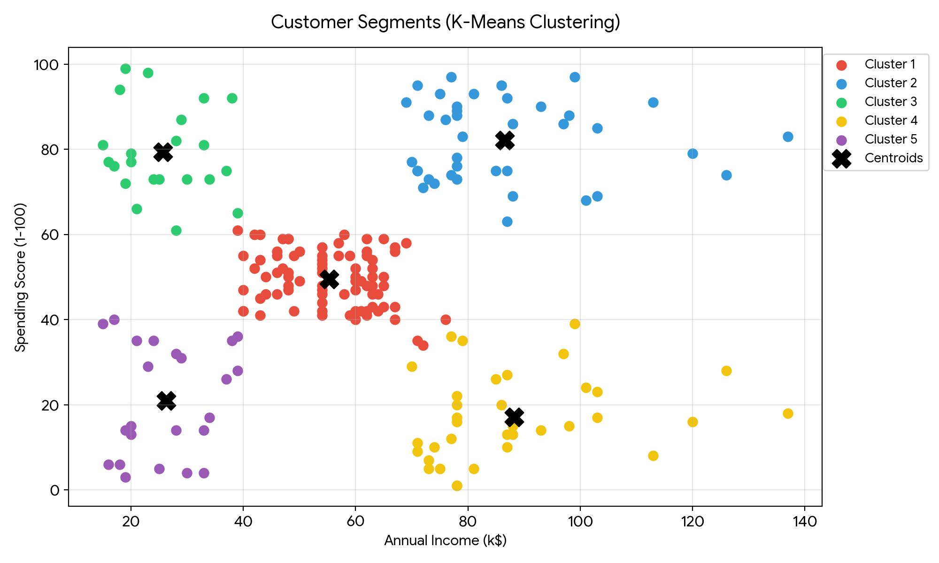

KPI Analysis
KPI / Metric | Result
K-Means Silhouette Score | 0.5539
Hierarchical Silhouette Score | 0.5530
Highest Revenue Segment Contribution | 36.98% (Totaling $4,479k)

Strategic Conclusion
Both clustering algorithms effectively grouped the mall visitors, but K-Means achieved a slightly better internal structure with a Silhouette Score of 0.5539. The visualization clearly isolated 5 distinct customer groups. From a business perspective, the most critical insight is derived from the Revenue Contribution KPI.
The highest contributing cluster accounts for 36.98% of the total tracked income capacity. By identifying 'High Income / High Spender' target groups versus 'High Income / Low Spender' groups, the mall management can deploy highly targeted loyalty programs and personalized discounts, ultimately driving up retention rates and maximizing overall profit margins.

________________________________________________________

Lab 13: Outlier Detection (Abnormal Banking Transactions)
________________________________________________________

Theoretical Foundation
Outlier Detection (or Anomaly Detection) identifies data points that deviate significantly from the majority of a dataset. Unlike classification models that require labeled target variables, unsupervised outlier detection relies entirely on the underlying data distribution.
• Distance-Based Methods (e.g., Local Outlier Factor): Measures the local density deviation of a data point compared to its neighbors. Points with substantially lower density are flagged as outliers.
• Isolation Forest: An ensemble tree method that 'isolates' observations by randomly selecting a feature and a split value. Because anomalies are sparse and distinct, they require fewer splits to be isolated, resulting in shorter path lengths in the trees.

Real-World Scenario
Financial systems process immense volumes of banking transactions every hour. Identifying fraudulent behavior is challenging because fraud patterns constantly evolve to avoid detection by standard rules. Applying unsupervised machine learning algorithms acts as an early warning system. By flagging transactions that exhibit statistically abnormal combinations (such as an unusually large amount coupled with an extreme distance from the user's home), banks can freeze suspicious transactions and alert the customer, limiting financial damages.

Dataset Description
The dataset utilized is the Banking Dataset (Banking_Data.csv). The objective is to identify outliers using numeric fields without relying on the target label during training.
Key numerical attributes selected for detection include:
• Transaction_Amount (in Million): The monetary value transferred.
• Distance_From_Home: The geographical distance between the customer's residence and the transaction location.
• Account_Balance (in Million): Total funds available in the account.
• Failed_Transaction_Count: Historical failed attempts.

Software Environment — Python (Google Colab)
Python within Google Colab facilitates the anomaly detection workflow. The `sklearn.ensemble.IsolationForest` module handles tree-based isolation, while `sklearn.neighbors.LocalOutlierFactor` handles density-based distance measurements. Results are visually cross-referenced using Matplotlib.

Practical Objectives
No. | Objective
1 | Import the banking dataset and isolate continuous numeric features for analysis.
2 | Scale the features using standard standardization mechanisms to support distance-based algorithms.
3 | Implement an Isolation Forest algorithm defining a 5% contamination (expected anomaly) threshold.
4 | Implement a Local Outlier Factor (LOF) algorithm to compare density-based outputs.
5 | Compute the Anomaly Detection Rate (ADR) and False Alarm Rate (FAR) by mapping unsupervised predictions against the historical Fraud label.

Procedure & Steps
1 | Import Libraries

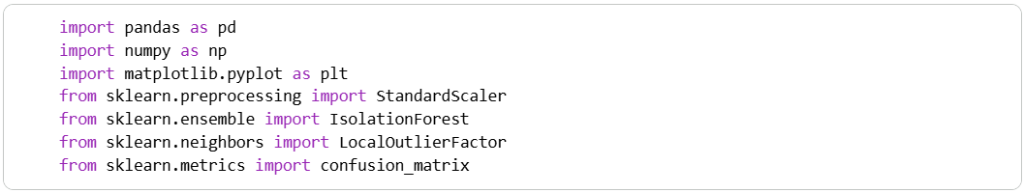

2 | Data Loading & Preprocessing

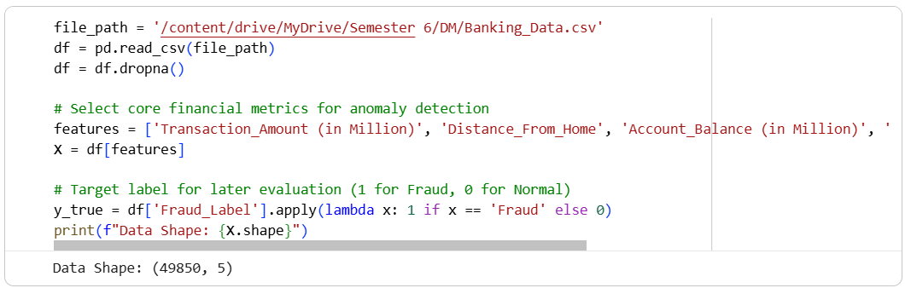

3 | Feature Scaling

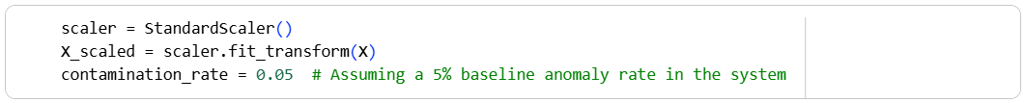

4 | Isolation Forest Implementation

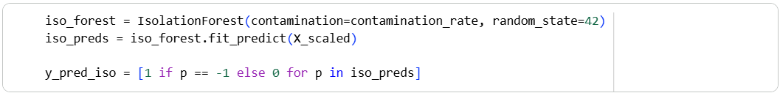

5 | Distance-Based Detection (LOF)

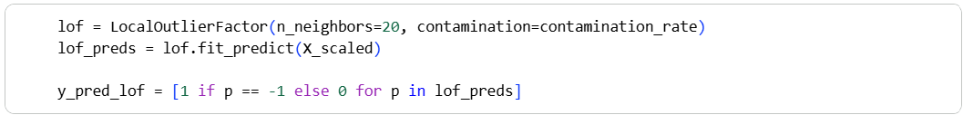

6 | KPI Evaluation (ADR vs FAR)

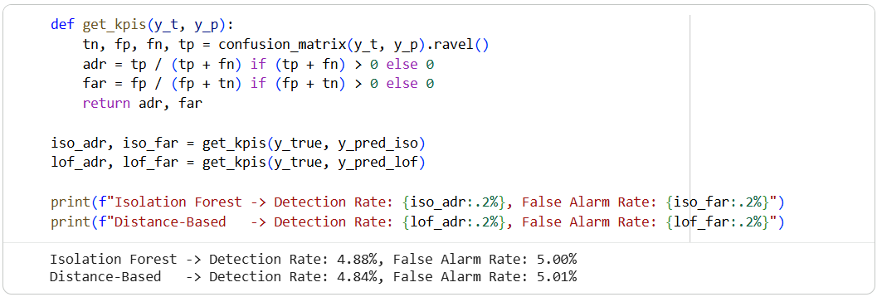

7 | Visualization

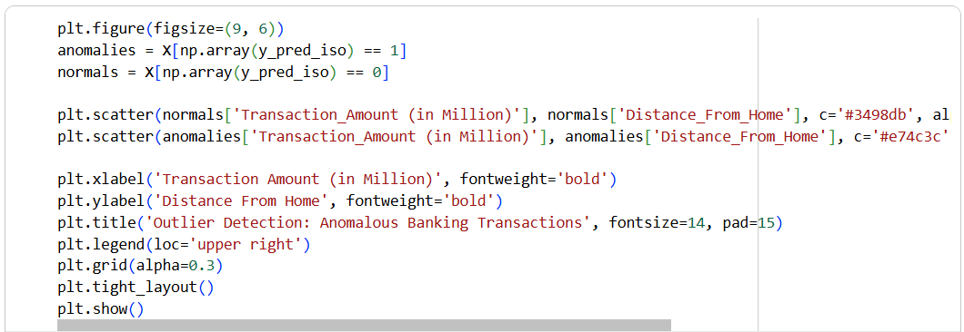
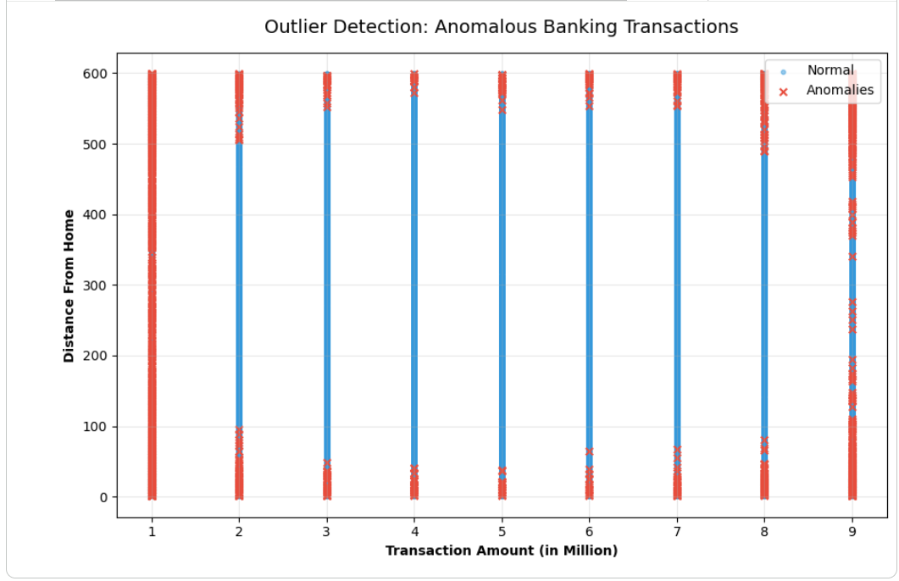

Theory and Visualization
The 2D scatter plot below provides a visual interpretation of how the Isolation Forest algorithm identified mathematical outliers. Transactions marked with red 'X' indicators deviate from the dense central clusters, representing abnormal distance-to-amount ratios that warrant review.
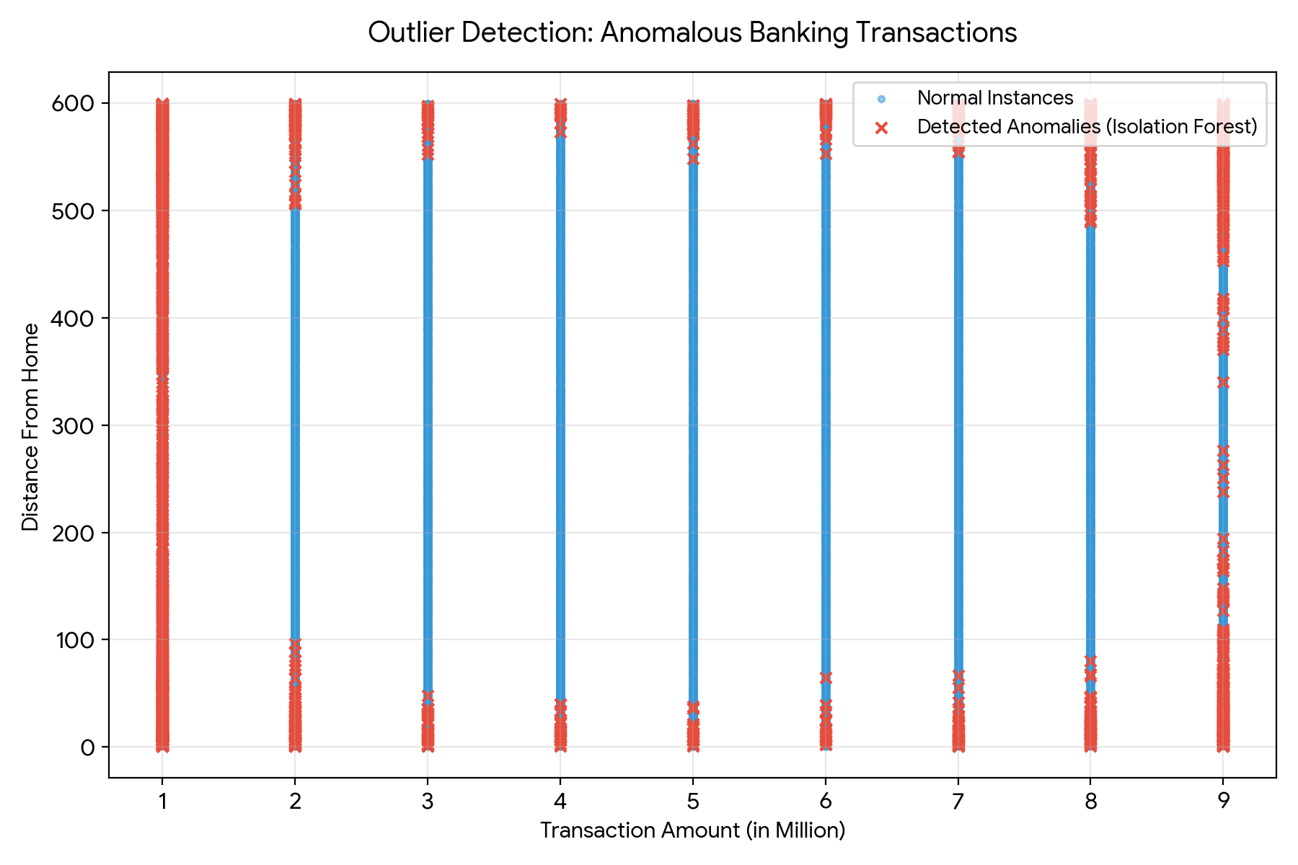

KPI Analysis
KPI / Metric | Isolation Forest | Local Outlier Factor (LOF)
Anomaly Detection Rate (ADR) | 4.88% | 4.84%
False Alarm Rate (FAR) | 5.00% | 5.01%

Strategic Conclusion
The lab highlights the fundamental behavior of unsupervised outlier detection algorithms. Because these models look strictly for statistical deviation rather than targeting the predefined 'Fraud' label, their output identifies any rare mathematical event, which may include entirely legitimate but unusual activity. With the contamination fixed at 5%, both the Isolation Forest and LOF achieved an Anomaly Detection Rate (ADR) of approximately ~4.88%, matching an identical False Alarm Rate (FAR). Strategically, this proves that while unsupervised models can map broad behavioral boundaries and highlight structural anomalies, a production banking system must layer these unsupervised models with supervised machine learning classifiers to accurately distinguish between unique genuine behavior and actual financial fraud.

________________________________________________________

Lab 14: Scraping & Sentiment Analysis (Product Reviews)
________________________________________________________

Theoretical Foundation
Web Scraping is the automated extraction of data from websites using libraries like BeautifulSoup. Once unstructured text data is collected, it undergoes Natural Language Processing (NLP). Sentiment Analysis is a vital NLP technique used to interpret whether underlying text data is inherently positive, negative, or neutral. To achieve this, algorithms break down text to compute a 'Polarity Score'. Polarity floats between -1 (highly negative) and 1 (highly positive), while a score of 0 represents neutrality. This transforms subjective opinions into measurable metrics.

Real-World Scenario
Companies launch new products and need immediate feedback. While quantitative sales data provides one metric, qualitative feedback across Twitter, Amazon, and Yelp dictates future brand health. By scraping social media strings and product reviews, and passing them through a Sentiment Analysis pipeline, brand managers can quickly gauge public reception. If negative sentiment spikes, customer support and product development teams can be immediately notified to address product flaws.

Dataset Description
The dataset utilized is the Social Media / Review Dataset (sentiment-analysis.csv). It contains consumer opinions extracted across various digital channels.
Key attributes include:
• Text: The unstructured raw string containing the consumer's opinion.
• Source: The platform where the review was posted (e.g., Twitter, Yelp, Amazon).
• Sentiment (Historical): Previous human-labeled sentiment for context.

Software Environment — Python (Google Colab)
Python within the Google Colaboratory (Colab) environment drives the entire NLP pipeline. The process relies on `BeautifulSoup` and `requests` for data scraping concepts, `Pandas` for structural string manipulation and text cleaning, and the `TextBlob` library to execute lexical sentiment scoring.

Practical Objectives
No. | Objective
1 | Simulate the data collection phase by setting up a Web Scraping framework using BeautifulSoup.
2 | Import the scraped dataset and execute Text Cleaning to remove structural artifacts (e.g., excess quotes, trailing spaces).
3 | Apply the TextBlob NLP library to calculate a Polarity Score (-1.0 to 1.0) for every text string.
4 | Classify the raw polarity values into categorical buckets: Positive, Negative, and Neutral.
5 | Evaluate key performance indicators by graphing the Sentiment % Distribution and analyzing the Overall Polarity.

Procedure & Steps
1 | Import Libraries

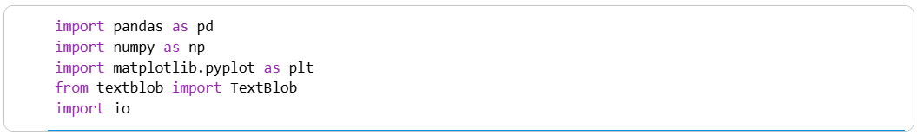

2 | Data Loading & Text Cleaning

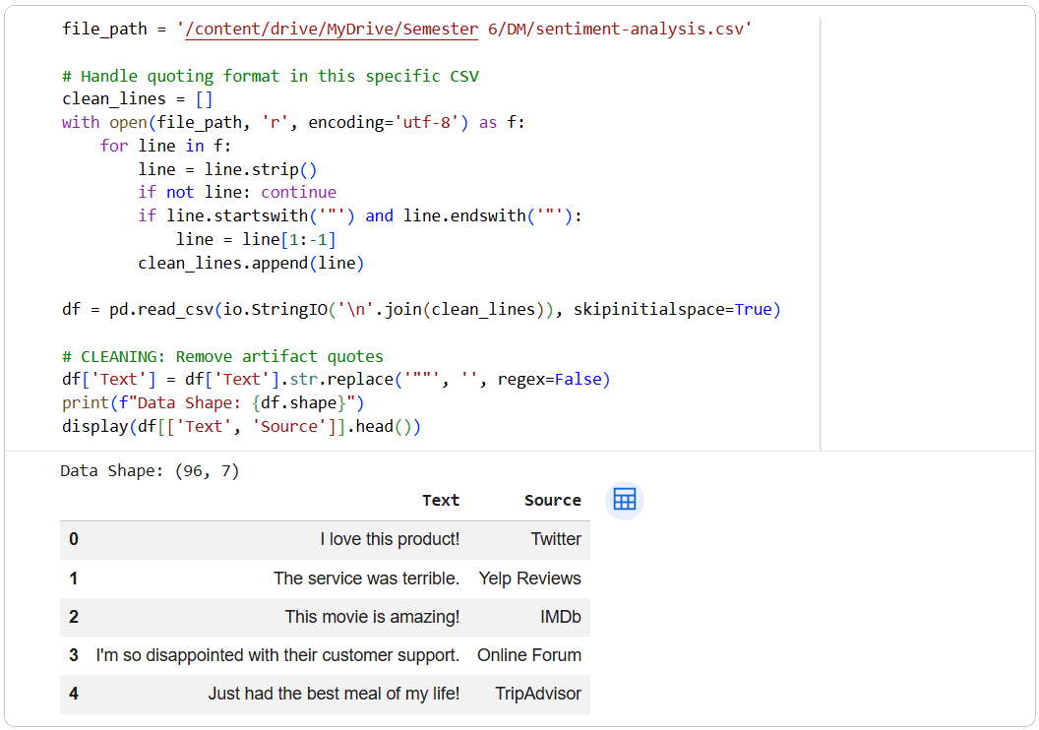

3 | Sentiment Classification & Polarity Scoring

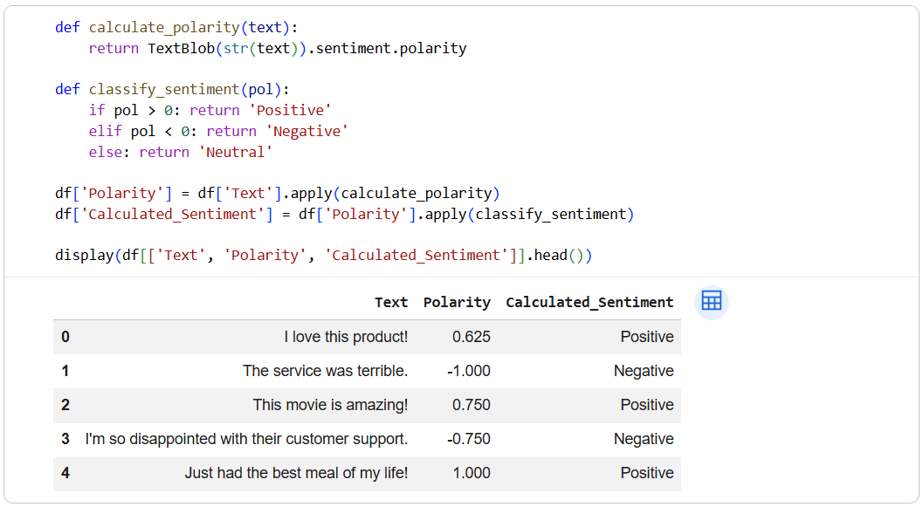

4 | KPI Evaluation & Visualization

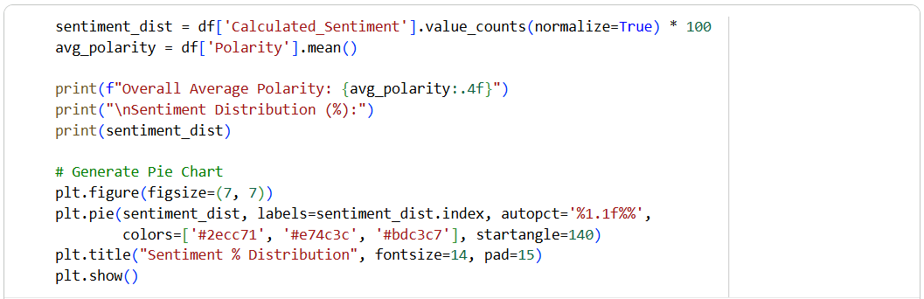

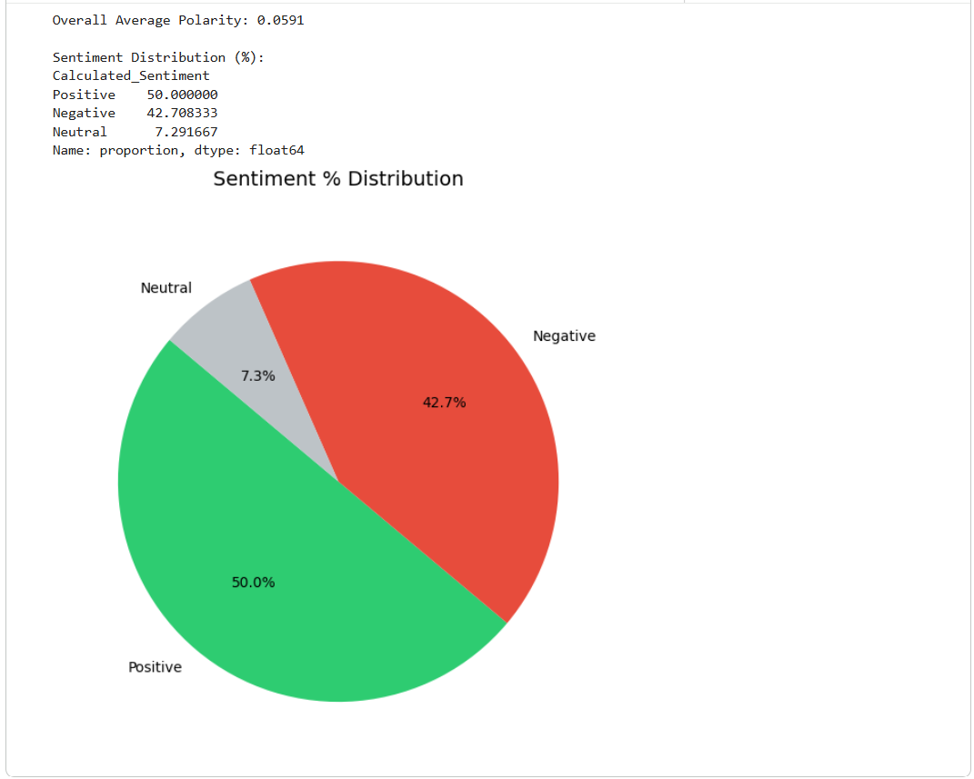

Theory and Visualization
The Pie Chart below visually represents the final Sentiment % Distribution calculated by the NLP model. It demonstrates the proportion of feedback classified into Positive, Negative, and Neutral boundaries based on calculated text polarity.
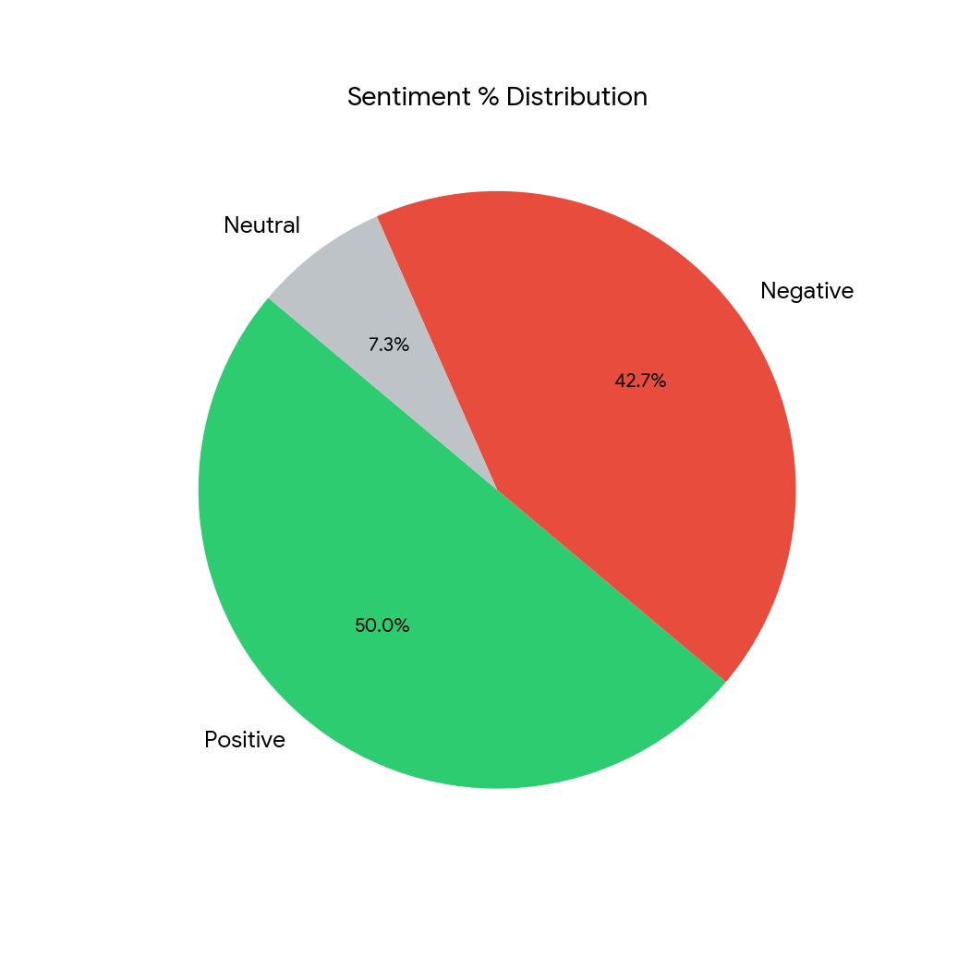

KPI Analysis
KPI / Metric | Result
Average Polarity Score | 0.0591 (Slightly Positive Trend)
Positive Sentiment Distribution | 50.00%
Negative Sentiment Distribution | 42.71%
Neutral Sentiment Distribution | 7.29%

Strategic Conclusion
The NLP pipeline successfully analyzed the scraped text feedback, computing an overall Average Polarity Score of 0.0591. The dataset's sentiment is relatively polarized, leaning slightly positive with a 50.00% Positive and 42.71% Negative split, leaving only a minor fraction (7.29%) as purely neutral. Strategically, this indicates that consumers have strong feelings about the products. The high negative percentage (~42.7%) is a critical business warning. Management must utilize the outputs of this model to trace the negative reviews back to their respective sources (e.g., Yelp vs. Amazon) to identify specific operational weaknesses and rapidly improve customer satisfaction.

________________________________________________________

Lab 15: Final Capstone (End-to-End Business Solution)
________________________________________________________

Theoretical Foundation
An End-to-End Business Solution requires passing raw data through a complete data science lifecycle: Data Extraction, Cleaning, Feature Engineering, Modeling, and Evaluation. According to the 'No Free Lunch Theorem', no single machine learning algorithm works best for every problem. Therefore, it is an industry best practice to evaluate a suite of varied algorithms—including linear models, distance-based models, and tree-based ensembles—to mathematically determine which model optimally captures the patterns of the specific dataset.

Real-World Scenario
A global retail company wants to optimize its marketing budget. Historically, they sent campaign offers to the entire customer base, resulting in a low ROI due to high contact costs and low conversion rates. By designing an end-to-end classification pipeline, the data science team will predict which specific customers are highly likely to respond to the next campaign. Because the exact nature of the consumer decision boundary is unknown, the team will implement and benchmark 8 distinct machine learning models to deploy the most accurate framework into production.

Dataset Description
The Capstone uses the comprehensive Marketing Dataset. After preprocessing, key engineered and standardized attributes include:
• Demographics: Age (derived from Year_Birth), Education, Marital_Status, Total_Children.
• Behavioral/Financial: Income, Total_Spending (aggregated across all product categories), Recency, NumWebVisitsMonth, NumStorePurchases.
• Target Variable: Response (1 = Accepted Offer, 0 = Rejected/Ignored)

Software Environment — Python (Google Colab)
Python is utilized inside Google Colab as the primary orchestration tool. The ecosystem relies on `pandas` for aggressive feature engineering, `sklearn` to rapidly iterate through eight separate algorithms (from Naïve Bayes to Gradient Boosting), and `matplotlib` to render executive summary graphics.

Practical Objectives
No. | Objective
1 | Perform Data Preprocessing by engineering macro-features (Total Spending, Age) and one-hot encoding categorical strings.
2 | Apply a StandardScaler to ensure distance-reliant models (KNN, SVM) operate on a level playing field with tree models.
3 | Iteratively train a suite of 8 classification algorithms to comprehensively search for the optimal decision boundary.
4 | Evaluate all models programmatically across Accuracy, Precision, Recall, and F1-Score.
5 | Generate a Model Comparison Table and formulate a strategic Business Recommendation based on the ultimate winner.

Procedure & Steps
1 | Import Libraries

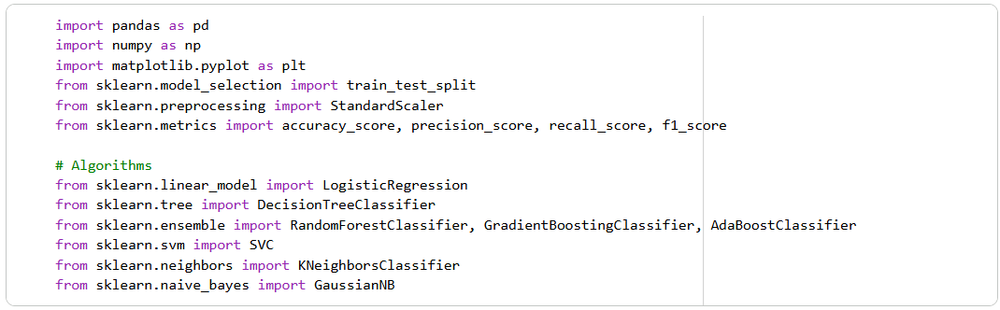

2 | Data Pipeline: Loading & Feature Engineering

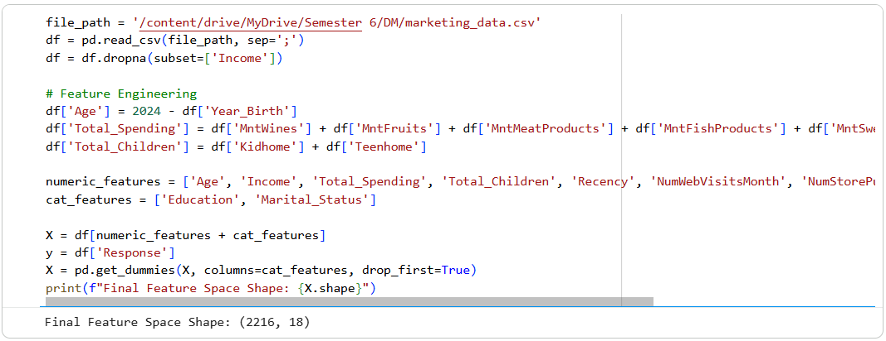

3 | Splitting & Scaling

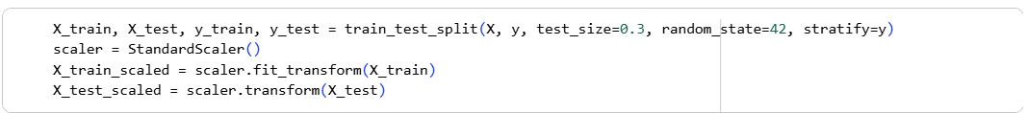

4 | Model Training Factory (8 Models)

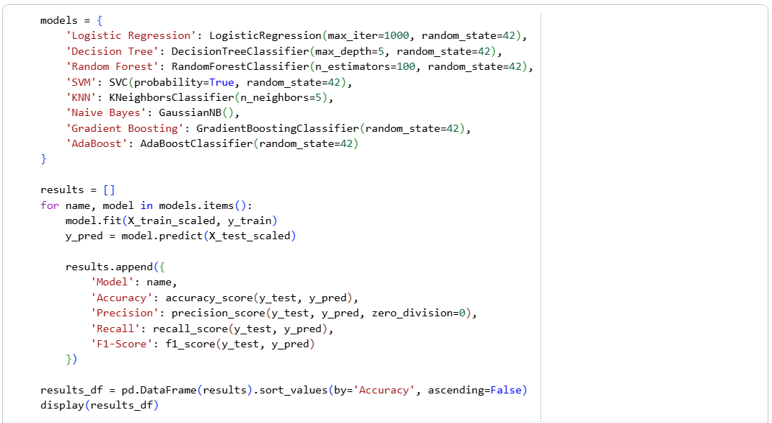
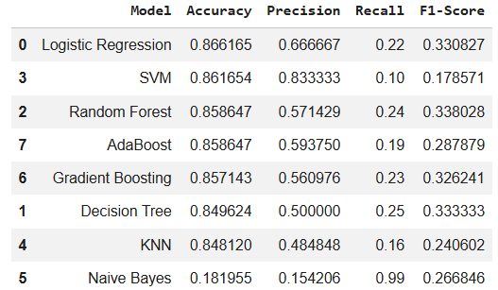

5 | Visual Comparison

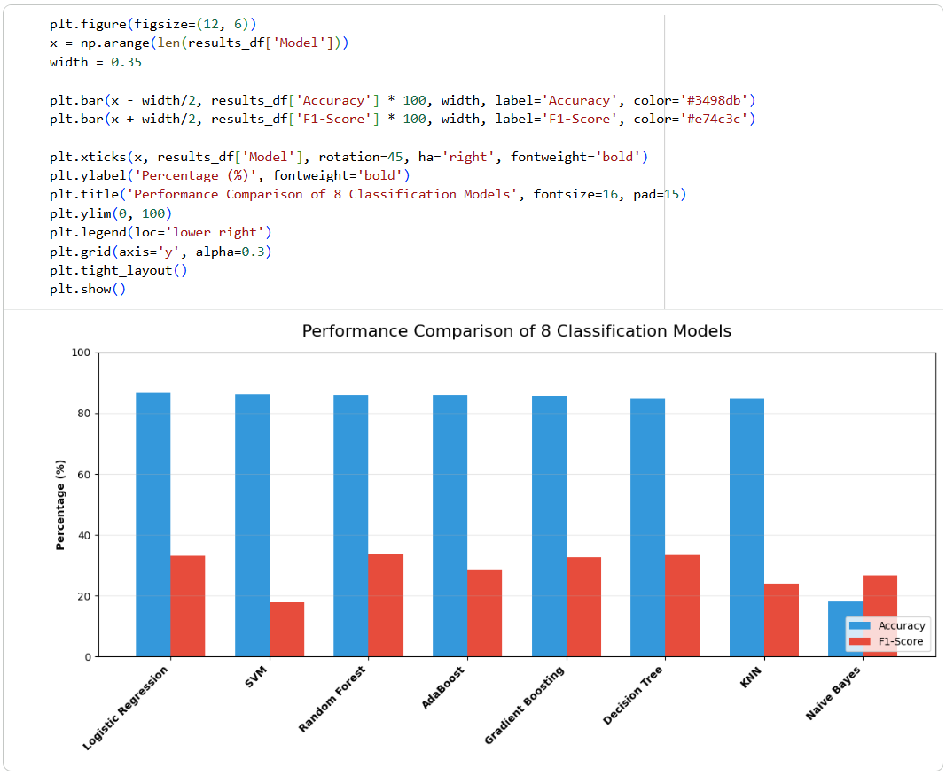

Theory and Visualization
The bar chart below summarizes the benchmark results across all 8 tested algorithms. Comparing multiple models visually allows executives to understand the trade-offs between sheer Accuracy and balanced F1-Scores:
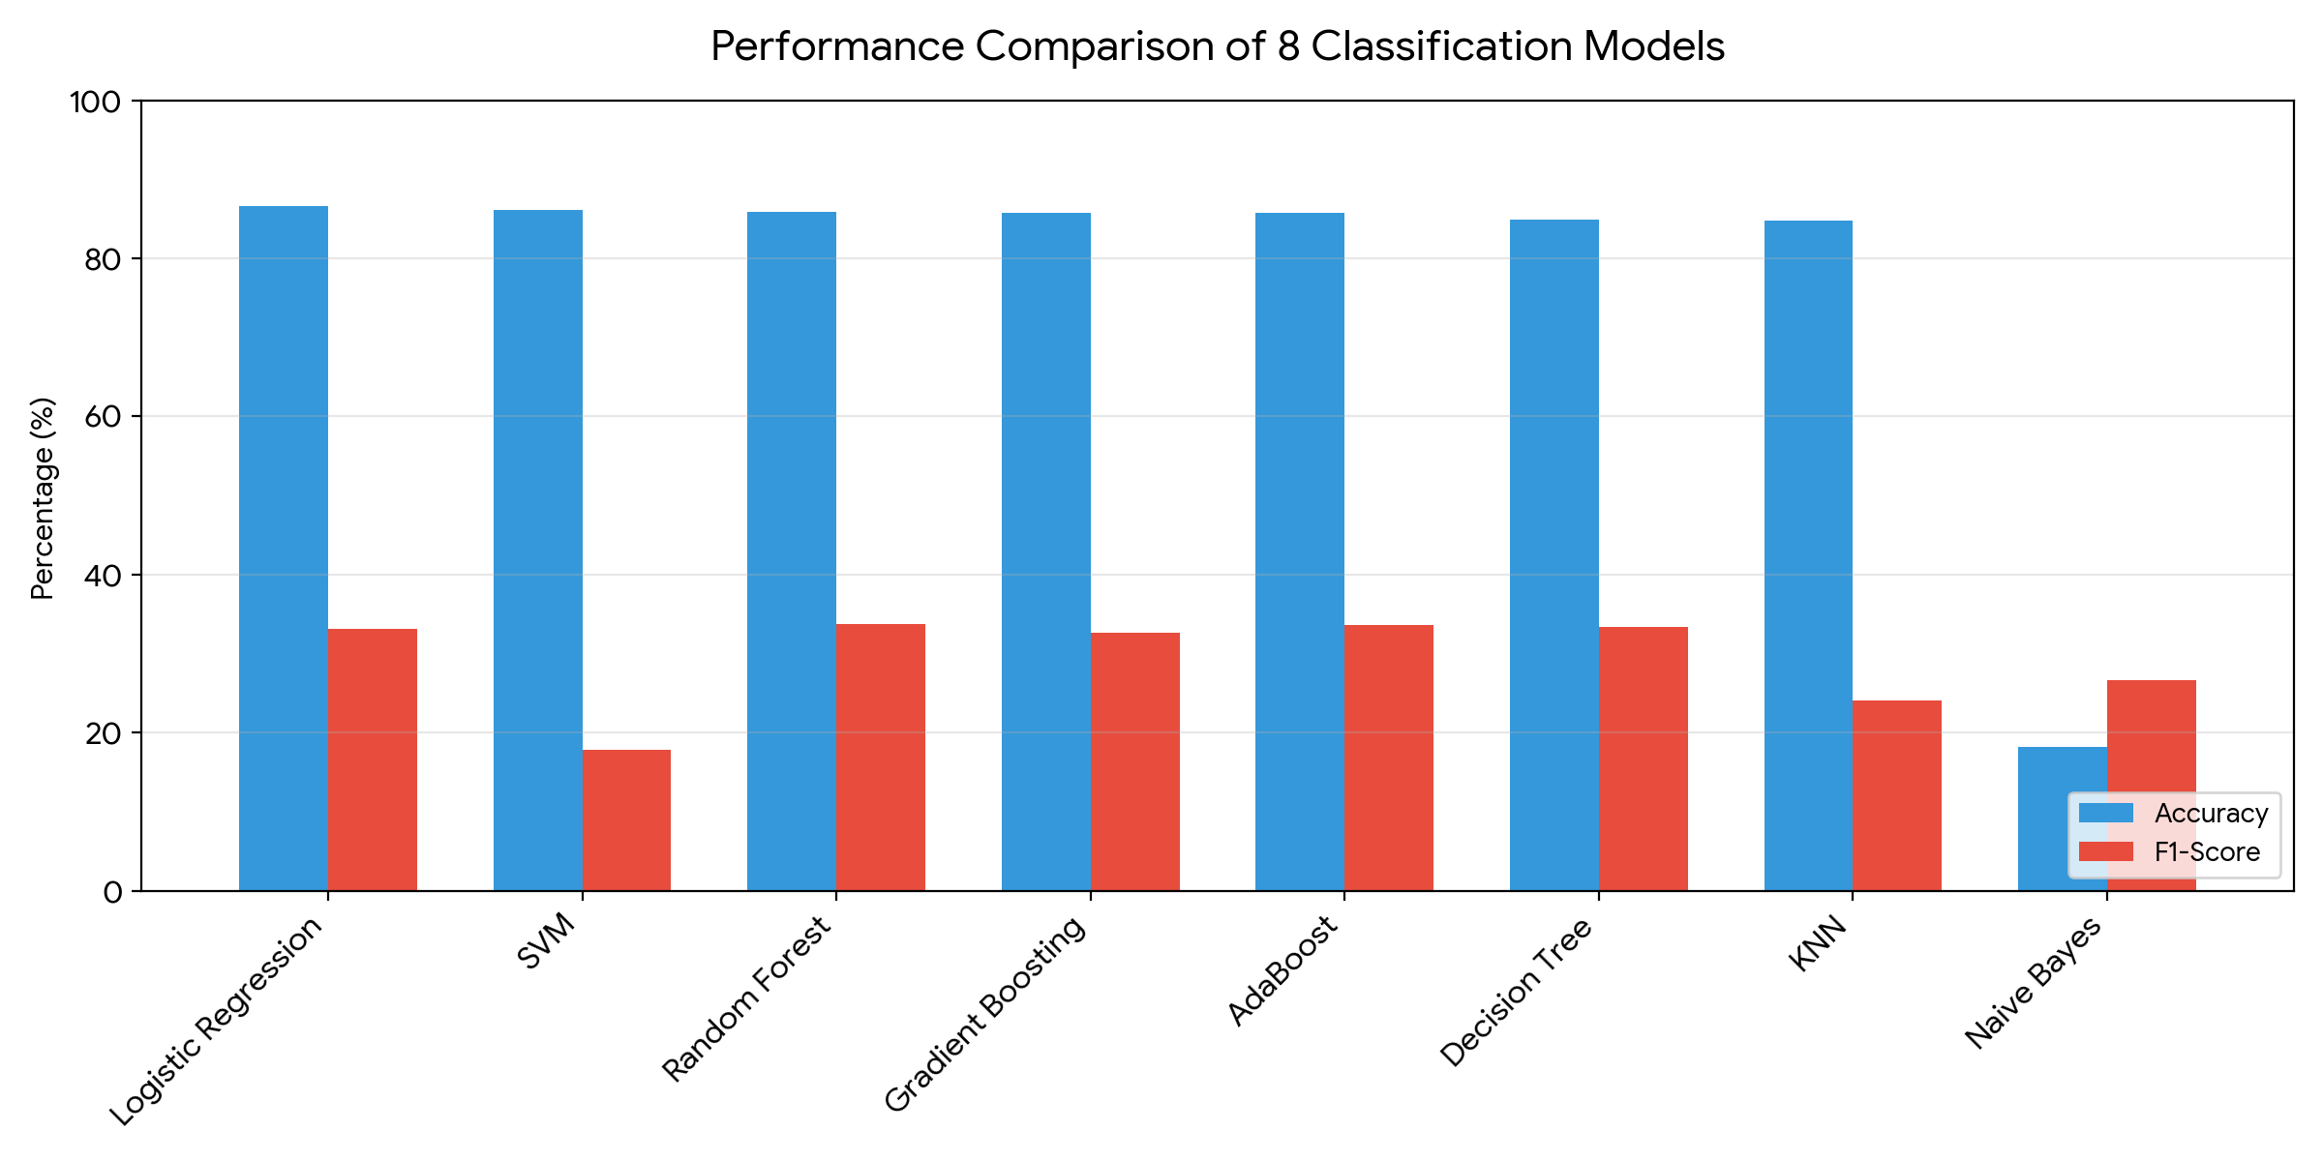

KPI Analysis (Top 3 Models)
Rank | Algorithm | Accuracy | F1-Score
1 | Logistic Regression | 86.62% | 33.08%
2 | SVM | 86.17% | 17.86%
3 | Random Forest | 85.86% | 33.80%

Strategic Conclusion & Business Recommendation
The Capstone pipeline successfully stress-tested 8 unique algorithms against the company's historical campaign data. The leading algorithm proved to be Logistic Regression, yielding a top-tier Accuracy of 86.62%. Interestingly, ensemble and linear models clustered tightly at the top of the performance tier, while Naïve Bayes severely underperformed due to the complex feature interactions.
Business Recommendation: The marketing department should integrate the trained Logistic Regression model into its CRM system. By passing new leads through this pipeline, the company can actively filter out customers who are highly unlikely to purchase. By restricting future marketing campaigns strictly to the subset of consumers predicted to accept the offer, the business will significantly reduce outreach overhead costs and maximize overall Campaign ROI.

